Testing Behavior Dynamic Models to Predict Choice
in a Non-Stationary Two-Choice Foraging Environment

David J. Cox^{1, 2}

¹ Endicott College; ² Mosaic Pediatric Therapy

Conflict of Interest: None.

Funding: None.

Correspondence: David J. Cox, dcox@endicott.edu

AI Disclosure: During the preparation of this work the author used Claude Code (Claude Opus 4.6, Anthropic, 2025) to program and deploy the experiment, and to draft and improve the efficiency of the code used for model testing and general analytics. After using this tool, the author reviewed and edited the code as needed and takes full responsibility for the content of the published article.

Abstract

Between the 1970s-1990s, researchers proposed several dynamic models of choice to explain how organisms adjust responding under changing contingencies (e.g., melioration, kinetic model, behavioral momentum, hill-climbing). Although widely debated, these models were rarely tested against one another on the same dataset, and alternative models from related sciences similarly predict individual choice based on contact with reinforcement. The present study revisits this literature by fitting 22 models to trial-level choice data from 60 humans completing a four-phase, non-stationary, two-option foraging task with regime shifts, contingency reversals, and perturbation probes. Models included three baseline heuristics, six historical models, three reinforcement-learning (RL) models, three hidden Markov models (HMMs), three foraging models, and four empirical dynamical models (EDM). Using AIC, HMMs with 3-4 latent states performed best (mean AIC = −2,010 to −4,183) followed by RL (≈ 1,040), historical models (≈ 1,052), then foraging models (≈1,216). Next-response predictive accuracy showed a similar pattern: HMMs performed best (≈ .88), followed by EDM (.74), RL (.69), historical (.66), foraging (.66) and baseline models (.53). Overall, state-switching architectures may better describe and predict choice in dynamic contexts where steady-state behavior is unlikely to emerge. Regardless, much work remains to predict response-by-response behavior dynamics across varying environmental contexts.

Keywords: behavior dynamics, behavioral momentum, hidden Markov models, matching law, melioration, nonlinear dynamic

Testing Behavior Dynamic Models to Predict Choice in a Non-Stationary
Two-Choice Foraging Environment
Between the 1970s and 1990s, several competing models were proposed to describe the processes whereby behavior adjusts dynamically to changing reinforcement contingencies. Melioration theory proposed that organisms continuously shift responding toward whichever alternative currently yields the higher local reinforcement rate, with the matching law emerging as the equilibrium of this process (e.g., Herrnstein & Vaughan, 1980; Vaughan, 1981). A hill-climbing account assumed organisms make local adjustments to maximize momentary return, producing trajectories that may or may not converge to global optima depending on the reinforcement landscape (e.g., Hinson & Staddon, 1983). A kinetic model formalized choice dynamics as differential equations governing the flow of behavior between alternatives, with rate constants analogous to those in chemical kinetics (e.g., Myerson & Hale, 1988; Myerson & Miezin, 1980). And, behavioral momentum theory characterized the persistence of behavior under disruption in analogy to physical momentum, with reinforcement rate in a stimulus context determining resistance to change (e.g., Nevin, 1992; Nevin et al., 1990).
Each of the above models were proposed as competing process-level accounts of a phenomenon that steady-state, equilibria models could describe but not directly explain. For example, how exactly does behavior get to a matching equilibrium, and what happens when it is disturbed? A 1992 special issue of the Journal of the Experimental Analysis of Behavior (JEAB) on behavior dynamics arguably represents the accumulation of research on dynamical systems approaches to answering this question. In that 1992 issue, several researchers argued that the temporal structure of behavior (e.g., transient dynamics, oscillations, path dependence, sensitivity to perturbation) constituted legitimate scientific phenomena that behavior analysts should be able to quantitatively describe and explain, as opposed to a methodological artifact to be ignored with preference toward analyzing steady-state responding.
Despite several process-level accounts of behavior dynamics being proposed, however, researchers never quite followed up to formally test the various models using the same dataset. Rather, each model was often evaluated against simulated data or against specific empirical phenomena for which it was designed, making cross-model comparison difficult. One notable exception was Staddon’s (1988) comparative evaluation of quasi-dynamic models. In that paper, Staddon compared melioration with a ratio-invariance account, arguing that melioration could not explain certain transient choice patterns (e.g., spontaneous recovery of preference after disruption), but a model where organisms maintain a constant ratio of behavior to reinforcement (ratio-invariance) provided a better account of the transition dynamics between steady states. Regardless, the steady-state tradition within behavior analytic research largely maintained its dominance, quantitative behavior analysis continued to focus heavily on the matching law and its extensions, and the behavior dynamics program remained a domain of “promising but incomplete” contributions (Galbicka, 1992).
Relatedly, researchers have also yet to fully explore connections between behavior dynamic models from related scientific fields meant to describe similar behavior-environment contexts. Some work has been published demonstrating substantial overlap between delay-reduction theory and foraging predictions (e.g., Abarca & Fantino, 1982; Fantino & Abarca, 1985) as well as studying energy-budget models through an operant lens (e.g., Pietras & Hackenberg, 2001; Pietras et al., 2008, 2013). However, these efforts focused on a narrow overlapping slice from each tradition. As one example of a broader approach, foraging theory offers a set of quantitative models such as the marginal value theorem (Charnov, 1976) which provides a principled, quantitative prediction that an organism should leave a depleting resource patch when the instantaneous return rate drops below the average return rate across all available patches. This framework and its extensions (e.g., Stephens & Krebs, 1987) were designed to describe and predict the kinds of depleting-and-recovering resource environments that bear similarity to concurrent VI schedules. However, the specific foraging-derived models have not typically been compared directly with behavior-analytic-dynamic models (e.g., melioration, behavioral momentum, resistance to change) using common datasets and quantitative model-comparison methods.
Several factors may have contributed to this portion of the research literature being left idle and research traditions isolated. First, different models were designed for different preparations and data types. Melioration addressed concurrent-schedule allocation; behavioral momentum addressed resistance to disruption; the kinetic model addressed transition dynamics between steady states. Comparing them required a task that simultaneously produced the phenomena all models were designed to explain. That is, changing contingencies, transition dynamics, perturbation responses, and sustained non-stationarity. No standard preparation provided all these simultaneously, per se.
Second, the computational tools for rigorous model comparison were less accessible in the 1980s and 1990s. Information-theoretic model selection (Akaike, 1998; Burnham & Anderson, 2002), now standard, may not have been as widely adopted during the period of active behavior-dynamic model development. Rather, models were often evaluated by visual comparison of predicted and observed trajectories, or by goodness-of-fit (e.g., VAC) to specific quantitative benchmarks, rather than by formal model comparison on held-out data or penalized likelihood criteria.
Third, and perhaps most impactful, modern dynamical systems toolkits that allow for easy characterization of behavior dynamic phenomena were not available until recently. For example, recurrence quantification analysis (Webber & Zbilut, 2005), empirical dynamic modeling (Sugihara et al., 2012), and hidden Markov models (Rabiner, 1989) are all now standard analytic methodologies in the nonlinear dynamics literature. Relatedly, reinforcement learning (RL) within the artificial intelligence (AI) community used to be labor intensive, required advanced computer programming skills, and was comparatively immature compared to modern RL algorithms (Sutton & Barto, 2018). As such, process-level behavior dynamic models may have been proposed without ready access to the diagnostic tools needed to fully evaluate the underlying behavioral dynamic structure (e.g., linearity, equilibrium-seeking, continuous adjustment) and to easily compare which architectures were best designed to describe behavior dynamics.
The present study sought to help reinvigorate the behavior dynamics program with modern tools and broader model comparison. We designed a two-option, four-phase foraging task that produced dynamic phenomena that all models of behavior dynamics should be able to explain: regime shifts, contingency reversals, perturbation responses, and sustained non-stationarity. We then fit 22 models to choice sequences from 60 participants. The models spanned six families: six historical behavior-dynamic models from behavior analysis (generalized matching law, melioration, kinetic model, behavioral momentum, hill-climbing, ratio invariance), three foraging models from behavioral ecology (marginal value theorem [VT] threshold, patch-leaving threshold, and softmax VT), three modern reinforcement-learning (RL) models from the AI literature (Q-learning, Q-learning with dual learning rates, and Q-learning with forgetting), three hidden Markov models (with 2, 3, and 4 latent states), four empirical dynamic modeling approaches (simplex projection under two training regimes, S-map with linear and nonlinear localization), and three baseline heuristics (random, bias-only, and win-stay/lose-shift).
The central question in this work was how well these varying models of behavior dynamics could adequately account for choice trajectories in non-stationary environments. The results below are structured as an escalation. That is, we begin with overall model comparisons, then demonstrate specific empirical phenomena that exist in the temporal structure of behavior and that behavior dynamic models should be able to capture (i.e., transition dynamics, path dependence, hysteresis, individual differences). We then apply common nonlinear dynamical diagnostics (empirical dynamic modeling, convergent cross-mapping, recurrence quantification analysis) to characterize the properties of the behavior dynamics themselves. The overall purpose of this work was not to identify a “winning model”. Rather, the goal was to better understand how each model performs relative to one another, what each might miss, and what model architecture might be needed to account for the full structure of choice as it unfolds in time.
Method
Participants
Sixty participants (N=60) were recruited through Prolific, an online platform that allows requesters (e.g., researchers) to post human intelligence tasks, and task completers (e.g., research participants) to complete the posted tasks in exchange for monetary compensation. All participants provided informed consent via an electronic consent form. The study was approved by [IRB information redacted for blind review]. Participants received a base payment averaging $12/hr with no performance-based bonus.

Task
The task was a browser-based two-option foraging environment implemented in HTML, CSS, and JavaScript. Participants were presented with two response buttons (“Option A” and “Option B”) and could click either at any time, subject to a 200-ms cooldown. A live leaderboard was visually present on the upper right portion of the screen throughout the experiment and displayed the participant’s running point total alongside simulated scores from fake prior participants. As the participant earned points and surpassed the point totals of fake participants on the leaderboard, their ranking visually moved up the leaderboard in real-time.
Throughout the experiment, each response option was associated with a dynamically changing unsignaled value V bounded in [0, 1] and that determined the probability of contacting reinforcement (10 points) following each response. V for both options was initialized at 0.70 at the start of the experiment. Following each click, three things occurred. First, both options recovered their value V toward 1 based on elapsed time: V_{i} $←$ min(1, V_{i} + r_{i} $⋅$ $Δ$t), where V_{i} is the response option’s current value and r_{i} is the response option’s rate of recovery per time (see below). Second, the chosen option’s current V served as the Bernoulli probability of points being delivered since it was bounded between 0 and 1. Finally, the chosen option was depleted according to: V_{chosen} $←$ max(0, V_{chosen} $-$ d), where d is the depletion magnitude subtracted from the chosen option’s value following each response. Depletion (d) was constant across all phases and response options (d_{A} = d_{B} = 0.12).
Before the experiment proper started, each participant completed a practice block where they could respond to each alternative and learn how the experimental task worked. The practice condition lasted 20 s using parameters identical to what the participants contacted in Phase 1 (see below). At the end of the practice period, participants contacted a 5 s inter-condition interval where a countdown timer and language indicated when the experiment would formally begin.
The experimental portion task lasted 360-s (6-min) and was divided into four 90-s phases that were not differentially signaled to participants (i.e., mixed-schedule; Table 1). Phase 1 established a symmetric baseline (r_{A} = r_{B} = 0.18/s, d_{A} = d_{B} = 0.12/click). Phase 2 introduced an advantage for responding on Option A (r_{A} = 0.24, r_{B} = 0.10). Phase 3 reversed the advantage to responding on Option B (r_{A} = 0.10, r_{B} = 0.24). And, Phase 4 imposed symmetric scarcity (r_{A} = r_{B} = 0.08). Asymmetries across phases, thus, were driven solely by differential recovery rates as opposed to differential costs of responding. This created a contingency structure in which sustained responding to one option (i.e., sustained harvesting in a foraging patch) reduced that option’s value while the unselected response option (i.e., neglected patch) recovered. Putatively, this contingency arrangement might punish perseveration and reinforce adaptive switching.
Models
We fit 22 different behavior dynamic models that can be categorized into six families. All models were fit to trial-level binary choice sequences via maximum likelihood with multi-start optimization via 10 random initializations. Models were compared using AIC and next-choice prediction accuracy (see below for model comparison details).
Baseline models. Three baseline models were used for comparison. The first was a random selection model where P(Choose A) = 0.5 on every trial, containing zero free parameters. The second was a bias probability model where P(Choose A) = constant estimated from each participant’s data, containing one free parameter. The third was a win-stay/lose-shift model (WSLS) where the probability of repeating a rewarded choice (p_{stay}) and switching after non-reward (p_{shift}) were estimated for each participant, thus, containing two free parameters.
Historical behavior-dynamic models. Six behavior-dynamic models from the behavior analytic literature were chosen based on their coverage of distinct proposed mechanisms for how behavior reaches steady-state equilibrium. Together, these six models span the major process-level accounts proposed during the 1970s-1990s: a descriptive steady-state relationship itself (generalized matching law); equilibrium-seeking via local rate comparison (melioration, ratio-invariance), continuous-time flow between response states (kinetic model), inertial resistance to disruption (behavioral momentum), and local gradient ascent on momentary return (hill-climbing). Each was selected because it: (a) appeared in the 1992 JEAB special issue on behavior dynamics or in the literature that issue was responding to, (b) made trial-level predictions that could be evaluated against binary choice sequences, and (c) proposed different mechanisms from the others, maximizing the utility of model comparison.
The first model was the generalized matching law (Baum, 1974):
log(B_{A}/B_{B}) = s $⋅$ log(R_{A}/R_{B}) + log b, (Equation 1)
where s is sensitivity and b is bias, fit to non-overlapping windows of local reinforcement and response ratios. To make next trial predictions, the fitted sensitivity (s) and bias (b) parameters were used to compute P(A) on each trial from the local reinforcement rates (Equation 1) where R_{A} and R_{B} are the within condition rates of reinforcement observed up to that trial. The predicted log ratio was converted to a choice probability via: P(Choose A) = $e^{-log⁡(\frac{B_{A}}{B_{B}})}$, yielding two free parameters (s, b).
The second model was melioration (Herrnstein & Vaughan, 1980; Vaughan, 1981) using exponentially weighted local reinforcement rates:
R_{i}(t) = (1 $-$ $α$) $⋅$ R_{i}(t $-$ 1) + $α$ $⋅$ reward_{i}(t), (Equation 2)
where R_{i}(t) is the local reinforcement rate estimated for option i at trial t; reward_{i}(t) is the binary reward outcome (1 or 0) received from option i on trial t; and $α∈$ {0, 1} is a learning rate controlling how heavily recent rewards are weighted relative to the running estimate. The local rate estimate was updated only for the chosen option on each trial with the unchosen option’s estimate carried forward unchanged. To make next trial predictions, the current local reinforcement rate difference (R_{A} − R_{B}) was passed through a logistic function (σ) with fitted inverse temperature β, which controls how deterministically the organism shifts toward the option with the higher local rate: with P(Choose A) = σ ($β$ $⋅$ (R_{A} $-$ R_{B})). This implementation yielded two free parameters (α, β).
The third model was ratio-invariance (Staddon, 1988). Ratio invariance proposes that organisms maintain a constant ratio of behavior to reinforcement, with choice proportion evolving toward an equilibrium determined by aggregate reinforcement rates rather than option-specific rate differences. The equilibrium choice proportion is:
s* = (R_{A} − ω) / (R_{A} + R_{B} − 2ω), (Equation 3)
where R_{A} and R_{B} are local reinforcement rate estimates and ω is an effect-ratio parameter capturing asymmetric effects of non-reinforcement. When ω = 0, this reduces to proportional matching: P(A) = R_{A} / (R_{A} + R_{B}). Local reinforcement rates were tracked using exponential recency weighting with a fixed learning rate of 0.1. To make next-trial predictions, the equilibrium proportion s* was computed from the current local rates and mapped to choice probability via P(Choose A) = σ(β · (s* − 0.5)), yielding two free parameters (ω, β).
The fourth was the kinetic model (Myerson & Miezin, 1980). The kinetic model treats choice proportion P(A) as a state variable evolving via a first-order differential equation:
dP/dt = k · R_{A}(t) · (1−P)− k · R_{B}(t) · P, (Equation 4)
where k is a rate constant governing the speed of preference change and R_{A}(t) and R_{B}(t) are locally estimated reinforcement rates computed over a rolling window. At equilibrium (i.e., when dP/dt = 0), Equation 4 yields P* = R_{A} / (R_{A} + R_{B}), recovering proportional matching. To make next trial predictions, the equation was discretized per trial and choice probability was computed as P(Choose A) = σ(β · (P − 0.5)), yielding two free parameters (k, β).
The fifth was behavioral momentum (Nevin et al., 1983) where response probability is determined by recent reinforcement in the current context, with disruption resistance proportional to reinforcement rate. In the present work, the behavioral momentum model tracks accumulated reinforcement rate r_{i} for each option within each experimental phase. At phase transitions, the prior phase’s reinforcement rates determine resistance to change. The residual strength of the prior preference decays as:
decay_{i}$(t)={10}^{-t∙\left(\frac{c+d∙r_{i}}{r_{i}^{0.5}}\right)}$, (Equation 5)
where t is trials since the phase transition, c is baseline disruption sensitivity, d is reinforcement-dependent disruption scaling, and r_{i} is the mean reinforcement rate for option i in the preceding phase. Net preference on each trial combines current-phase evidence with the decaying prior: prefer_{i}(t) = r_{i}^{current}(t) + r_{i}^{prior} · decay_{i}(t). Choice probability per trial is then P(Choose A) = σ(β · (prefer_{A} − prefer_{B})), yielding three free parameters (c, d, β).
The final historical behavior dynamic model was hill-climbing (Hinson & Staddon, 1983). The hill-climbing model estimates momentary reinforcement probability for each option based on time since last response and time since last reinforcer. Momentary value of option i is:
val_{i} = t_{i} + A / T_{i}, (Equation 6)
where t_{i} is time (in seconds) since the last response to option i (reflecting recovery of depleted value), T_{i} is time since the last reinforcer on option i, and A is a recency weighting parameter that controls the influence of recent reinforcement history. Choice probability per trial is then P(Choose A) = σ(β · (val_{A} − val_{B})), yielding two free parameters (A, β).
Foraging models. Three foraging models from the behavioral ecology literature were tested (Charnov, 1976; Stephens & Krebs, 1987). The first was a marginal value theorem (MVT) threshold model. The MVT predicts that an organism should leave a patch when the instantaneous return rate drops below the average return rate across all patches. The model computes a rolling reinforcement rate for the current patch (the option most recently chosen) and the overall average rate over a window of recent trials. If the current patch rate exceeds the average, the model predicts the participant stays; otherwise, it predicts a switch. The window size was selected from {5, 10, 15, 20, 30} trials to minimize negative log-likelihood, yielding one free parameter.
The second foraging model was a patch-leaving threshold model. Specifically, we used a simplified variant of patch-leaving threshold models wherein the participant switches response options when the current patch’s reinforcement rate drops below a fixed threshold θ which is estimated from the participant’s data. Thus, this model contains one free parameter (θ).
The third was a softmax MVT model. This is a probabilistic extension of MVT in which the probability of staying on the current patch is:
P(stay) = σ(β · (R_{current} − R_{average})), (Equation 7)
where R_{current} is the rolling reinforcement rate on the current patch, R_{average} is the overall rolling reinforcement rate, and β is an inverse temperature parameter. The window size was selected as in the MVT threshold model, yielding two free parameters (window, β).
Reinforcement-learning (RL) models. Five RL models from the artificial intelligence (AI) literature were also tested. The first was Q-learning (Sutton & Barto, 2018) using standard temporal-difference learning with a single learning rate ($α$) and inverse temperature ($β$), thus, containing two free parameters. Standard Q-learning maintains action values Q_{A} and Q_{B} (initialized at 0.5) and updates the chosen option on each trial via:
Q_{chosen}(t+1) = Q_{chosen}(t) + α · [r(t) − Q_{chosen}(t)], (Equation 8)
where α is the learning rate and r(t) ∈ {0, 1} is the reward outcome. And, choice probability follows a softmax rule: P(A) = σ(β · (Q_{A} − Q_{B})).
The second was Q-learning with dual $α$ that contains separate learning rates for positive and negative prediction errors, thus, containing three free parameters. The Q-learning with dual learning rates uses the same update rule but applies α⁺ when the reward prediction error (RPE = r(t) − Q_{chosen}) is positive and α⁻ when it is negative, yielding three free parameters (α⁺, α⁻, β).
The third was Q-learning with forgetting where the unchosen option’s Q-value decays toward a neutral point each trial, also containing three free parameters. Mathematically this takes the form:
Q_{unchosen}(t+1) = Q_{unchosen}(t) + φ · (0.5 − Q_{unchosen}(t)), (Equation 9)
where φ is a forgetting rate that pulls the neglected option’s value toward indifference. This model also has three free parameters (α, β, φ).
Hidden Markov models (HMMs). Three HMMs were tested where each had one of either 2, 3, or 4 latent states. Each used a Gaussian emission distribution over multivariate observation vector and a full transition matrix. The observation vector included four features: choice (binary), reward outcome (binary), rolling choice proportion, and inter-click (ICI) interval. Continuous features were standardized within each session.
An HMM assumes that observed choices y_{t} are generated by a latent state s_{t} ∈ {1, ..., K} that evolve according to a first-order Markov chain. The model is defined by three components: an initial state distribution π, where π_{k} = P(s₁ = k); a K × K transition matrix A, where A_{jk} = P(s_{t} = k | s_{t−1} = j); and emission distributions P(y_{t} | s_{t} = k) characterizing the multivariate behavioral profile within each latent state:
αₖ(t) = P(yₜ | sₜ = k) · Σⱼ Aⱼₖ · αⱼ(t−1), (Equation 10)
with αₖ(1) = πₖ · P(y₁ | s₁ = k), and where the emission for each state is multivariate Gaussian: P(yₜ | sₜ = k) = N(yₜ; μₖ, Σₖ). The number of free parameters scales with states and features such that the 2-state HMM contained 19 parameters, 3-state contained 32 parameters, and 4-state contained 47 parameters. States were fit via the Baum-Welch algorithm (expectation-maximization) with multiple random restarts, and the most likely state sequence was decoded via the Viterbi algorithm (Rabiner, 1989). Each model’s fitted parameters were used to reconstruct trial-level choice probabilities P(Choose A) for every click in each participant’s session. These continuous probabilities were thresholded at 0.5 to produce binary predicted choices (A vs. B), which were then compared against the participant’s actual choices to compute prediction metrics.
Nonlinear Dynamical Systems Diagnostics
In addition to model comparison, we applied four nonlinear dynamical systems (NDS) diagnostics to characterize the structure of behavior dynamics independent of any model’s assumptions. The first was empirical dynamic modeling (EDM) with simplex projection (Sugihara & May, 1990). EDM with simplex projection helps determine the optimal embedding dimension (E) for each participant’s time series choice data, providing a model-free estimate of the dimensionality of the underlying dynamical system. The time series x(t) is embedded in an E-dimensional state space using Takens’ delay embedding:
X(t) = [x(t), x(t−τ), x(t−2τ), ..., x(t−(E−1)τ)]. (Equation 11)
Predictions are formed by identifying the E+1 nearest neighbors of X(t) in the reconstructed attractor and computing a weighted average of their successors, with weights decaying exponentially with distance. Prediction skill is measured as the Pearson correlation between predicted and observed values (ρ) on the rolling choice proportion time series, and the E maximizing ρ estimates the effective dimensionality.
The second was S-Map analysis (Sugihara, 1994) which compares global linear and locally weighted nonlinear prediction models to assess whether behavioral dynamics were state-dependent. S-Map fits a locally weighted linear model at each point in the reconstructed state space:
x(t+1) = c₀ + Σᵢ₌₁ᴱ cᵢ · xᵢ(t), (Equation 12)
where the coefficients c are obtained by weighted least squares, with each library point X(j) receiving weight w(j) = $e^{\frac{-θ∙d(X\left(t\right), X\left(j\right))}{\overline{d}}}$, where d̄ is the mean distance and θ controls the degree of localization. When θ = 0, the model is globally linear; θ > 0 produces state-dependent (nonlinear) predictions. Improved forecast skill at θ > 0 indicates nonlinearity.
The third was convergent cross-mapping (CCM) (Sugihara et al., 2012). CCM tests for causal coupling between reward history and choice allocation using attractor reconstruction, providing directional evidence beyond a correlational matching law framework. If X causally influences Y, then information about X is encoded in Y’s attractor. CCM tests this by reconstructing the attractor from Y’s time series, M_{Y}, and using it to cross-map estimates of X:
X̂(t) = Σᵢ wᵢ · X(tᵢ), (Equation 13)
where tᵢ are the time indices of the E+1 nearest neighbors of Y(t) in M_{Y}, and weights wᵢ decay exponentially with distance. If the cross-map correlation ρ(X, X̂) increases with library length (convergence), this constitutes evidence that X causally influences Y.
CCM was conducted within each experimental phase separately to respect the stationarity assumption required by attractor reconstruction. For each participant and phase, the rolling choice proportion and rolling reward rate time series were extracted. Embedding dimension (E) was determined via simplex projection, and CCM was computed at five evenly spaced library sizes spanning from E + 2 to N − 10. Two cross-mappings were evaluated per library size: reward → choice and choice → reward. To aggregate across participants, library sizes were normalized to a proportion of each participant’s maximum library size (0 to 1) and averaged within five equal-width bins. This ensured all participants contributed to each point on the convergence curve.
Lastly, we used recurrence quantification analysis (RQA) (Webber & Zbilut, 2005) to quantify the deterministic structure, recurrence rate, and laminar trapping in choice sequences, characterizing the temporal organization of behavior. A recurrence plot is constructed from the embedded time series by computing:
R(i,j) = Θ(ε − ‖X(i) − X(j)‖), (Equation 14)
where Θ is the Heaviside step function and ε is a distance threshold (set to 0.1 in the current experiment). RQA quantifies the texture of this plot via recurrence rate (RR = fraction of recurrent points), determinism (DET = fraction of recurrent points forming diagonal lines of length ≥ l_{min}), and laminarity (LAM = fraction forming vertical lines), indexing periodicity, predictability, and state-trapping respectively.
Nonlinear Dynamical Systems Prediction
To test whether the temporal structure identified by the NDS diagnostics contains exploitable predictive information that parametric models miss, we also tested EDM simplex projection (Sugihara & May, 1990) as a model-free forecasting approach. Unlike the parametric models, simplex projection makes no assumptions about the underlying process generating choices. Instead, it reconstructs the attractor from the observed time series using Takens’ delay embedding (Equation 11), identifies nearest neighbors in the reconstructed state space, and uses their known successors to forecast the next (rolling-window) observation.
We evaluated simplex projection under two forecasting regimes. In the first, the library (training set) consisted of Phase 1 (symmetric baseline) data, and predictions were generated for all subsequent phases. This tested whether the attractor structure learned under baseline contingencies generalized to novel, unsignaled contingency changes. Here the assumption would be that behavior dynamics may change in level, but not in process across contingency changes. In the second, the library expanded cumulatively (effectively dropping the previous assumption). Specifically, all data up to trial t served as the library for predicting trial t + 1, with the initial library comprising the first 25% of each participant’s session. This regime parallels how the parametric model might operate in everyday settings where the predictions are updated with each new observation. For both approaches, the optimal embedding dimension (E) was determined from the training data via simplex projection (Equation 11), forecasted rolling P(Choose A) values were thresholded at 0.5 to produce binary choice predictions.
Finally, we also evaluated S-Map projection predictions (Sugihara, 1994), which extends simplex projection by allowing state-dependent (nonlinear) weighting of neighbors. Where simplex projection weights neighbors equally, S-Map applies an exponential kernel controlled by a nonlinearity parameter θ. When θ = 0, all neighbors contribute equally (equivalent to a globally linear model), while increasing θ gives greater weight to neighbors closer in state space, allowing the forecast to capture locally nonlinear dynamics. For each participant, S-Map was run using the same optimal embedding dimension E identified by simplex projection. We evaluated a linear S-Map (θ = 0) and a nonlinear S-Map using the θ that maximized forecast skill (ρ) on the training data. As with simplex projection, forecasted rolling P(Choose A) values were thresholded at 0.5 to produce binary choice predictions.
Analytic Strategy
The analysis proceeded in three stages. First, we present the overall model comparison to establish the relative standing of all 18 parametric models. Second, we demonstrate specific empirical phenomena that reveal underlying behavior dynamics that the parametric models may not be built to uncover (i.e., phase-transition dynamics, path dependence, hysteresis, and HMM state structure). Lastly, we present the NDS diagnostics to characterize the properties of the dynamics themselves and to test the pure data-driven approaches to predicting each click that are designed to exploit the underlying NDS structure (i.e., EDM models and S-Map models). This escalation structure was designed to move from “which model fits best” to “what kind of model architecture is needed” and finally “what if we try to use data-driven models from NDS directly”.
Results
All 60 sessions passed validation criteria (minimum 50 clicks, minimum 300 s duration). Participants produced a mean of 924 responses (SD = 200) over the 360-s task (Table 2). Mean overall reward rate was 0.54 (SD = 0.17), and mean switch rate was 0.24 (SD = 0.15). Choice tracked the changing contingencies across phases (Figure 1). Phase 1 (symmetric) produced near-indifference (M = 0.51, SD = 0.06); Phase 2 (A advantage) shifted allocation toward A (M = 0.65, SD = 0.08); Phase 3 (B advantage) reversed with mean allocation toward A = 0.35 (SD = .08); and Phase 4 (scarcity) returned choice to indifference (M = 0.49, SD = 0.04). These systematic shifts confirm that behavior was non-stationary and sensitive to the arranged contingencies in the experiment. Further, these are the data the dynamic models need to explain.
Model Comparison
Table 3 and Figure 2 present the model comparison results for all 18 parametric models. As expected, the baseline family of models performed worst overall. Median AIC was 1281.5 and average next-trial prediction accuracy was 0.54 (F1=0.37; MCC=0.07). All three had roughly identical average AIC (1,280-1,282). However, the win-stay/lose-shift (WSLS) model had the highest next-trial prediction accuracy (0.61) with the bias and random models predicting choice in the next trial approximately half the time. This suggests that choice sequences carried structure beyond what the simple heuristics, as computationally modeled here, could capture.
The foraging, historical behavior-dynamic, and RL models all performed somewhat comparably as families of models. From an AIC standpoint performance order was RL (mean AIC = 1043), historical behavior-dynamic (mean AIC = 1186), then foraging (mean AIC = 1216). However, all performed roughly equivalently on next-trial choice prediction with mean accuracies ranging 0.655-0.685, F1 ranging 0.606-0.740, and MCC ranging 0.212-0.489. That said, there are noteworthy observations relative to individual models. For example several models within these families performed worse than baseline models relative to AIC (patch-leaving, per-trial matching law), though each had higher next-trial predictive accuracy than the baseline models. The HMMs were the best performing family of models (mean AIC = -3096.50; mean next-trial predictive accuracy = 0.993). However, the two-state HMM showed the broadest variability with a negative AIC for 34/60 participants (56.7%) and higher positive AICs than all other models for 24/60 participants (40%).
Phase-Transition Dynamics
Phase transitions produced reliable shifts in choice allocation, but the temporal structure of those shifts was where models diverge from data (Figure 3). At the Phase 1 to 2 transition (symmetric to A-advantage), participants adapted with a mean / median lag of 8.52 s / 6.17 s (SD = 8.63 s). At the Phase 2 to 3 transition (A-advantage to B-advantage), adaptation lag increased to 11.10 s / 10.28 s (SD = 7.94 s). By Phase 3 to 4, adaptation was near-instantaneous with adaptation lag 3.24 s / 1.39 s (SD = 5.79 s).
These adaptation lags pose a specific challenge for some of the models (e.g., melioration and Q-learning), which predict smooth exponential transitions governed by a single learning rate. The observed lags were highly variable across participants (range spanning ~40 s), suggesting that no single rate parameter could account for the difference across phases nor the overall distribution. Behavioral momentum predicts slower transitions when prior reinforcement was richer, which is qualitatively consistent with the Phase 2 to 3 lag being longer than Phase 1 to 2. However, the behavioral momentum model lacks the mechanism to explain the near-instantaneous adaptation at Phase 3 to 4, when options became scarce simultaneously.
Path Dependence and Hysteresis
Melioration, matching, and Q-learning all assume that choice allocation is governed by an equilibrium-seeking process. If true, then the trajectory through advantage–choice space during Phase 2 (A-advantage) should be the mirror image of the trajectory during Phase 3 (B-advantage). Figure 4 displays a hysteresis analysis, plotting P(Choose A) against the unobserved advantage value (V_{A} − V_{B}; Panel A) and local reinforcement-rate difference (R_{A} − R_{B}; Panel B) as continuous trajectories through each experimental phase using rolling 10-second bins.
In raw coordinates (panels A and B), the Phase 2 and Phase 3 trajectories occupy different quadrants and follow visibly different paths. The proportion that participants chose option A remained around 0.5 during Phase 1 when response value and reinforcement rate were similar (i.e., around 0.0 on each x-axis). During Phase 2 when unobserved response value and reinforcement probability favored A (positive x-axis panels A and B), the trajectories moved and circled within the upper right quadrant settling at the end of Phase 1 around P(Choose A) of ~.65. Similarly, during Phase 2 when unobserved value and reinforcement probability favored B (negative x-axis panels A and B), the trajectories circled within the lower left quadrant settling at the end of Phase 2 around P(Choose A) of ~.35. Lastly, during Phase 4 where the unobserved values and reinforcement probabilities were again equal, the trajectories show how P(Choose A) moved back toward indifference.
To more easily see whether the trajectories were “mirror images” of each other, the right panels in Figure 4 normalize response proportions during the second and third phases relative to the higher-payout option (panels C and D). Here, two different patterns are observed. When P(Choose A) is plotted against unobserved value (Panel C), Phase 2 and Phase 3 trajectories follow different paths, max at different x-axis values, and arrive at slightly different final locations. The vertical separation constitutes hysteresis. That is, the same unobserved value difference (i.e., same point on the x-axis) produced different choice allocation depending on the history of contingency changes. In contrast, when plotted against local reinforcement rate (Panel D), the two trajectories are much closer to overlapping and have much more similar endpoints. This suggests that contacted reinforcement might be driving choice allocation along similar trajectories independent of the unobserved response option values. Similar plots for all individual participants are shown in the supplemental file.
Given that contact with reinforcement seemed to play a similar role in driving choice across Phases 2 and 3 at the group level. A natural next question was whether each participants P(Choose A) was optimal based on the contingencies in effect and their unique ICI. Figure 5 shows the observed P(Advantaged Option) (y-axis) relative to the optimal P(Advantaged Option) (x-axis) for each individual participant (individual markers). Optimal P(Advantaged Option) was computed for each participant by simulating the task dynamics at that participant’s observed median ICI. For each candidate allocation proportion (0.50 to 1.00 in steps of 0.01), 20,000 trials were simulated using the programmed recovery rates (0.24 and 0.10 per second) and depletion rate (0.12 per click), and the proportion yielding the highest reward rate was selected as that participant’s optimal allocation. Overall, 25/60 (41.7%) of participants responded within ±5% of optimal responding allocation in Phase 2 and 19/60 (31.7%) in Phase 3.
HMM State Structure
The HMM analysis helps understand why state-switching models outperformed process models. Using AIC, the 4-state HMM was identified as best for 54/60 participants (90%) and the 3-state model was best for the remaining 6/60 participants (10%). Figure 6 shows the behavior-environment characteristics identified by each of these models. For each participant, model parameters (emission distributions and transition probabilities) were estimated via the Baum-Welch algorithm, and each trial was then assigned to its most likely state via the Viterbi algorithm. Because state labels are relative within each participant, individual state means vary. Some participants’ “exploring” states had choice proportions near ceiling or floor, indicating that the Viterbi algorithm effectively split one exploitation mode into substates rather than capturing a qualitatively distinct exploratory mode. The top row in Figure 6 shows the state space along all analyzed dimensions (i.e., P(Choose A), P(Reinforcement) per click, and median ICI) along with where HMM identified states landed within the total state space (different markers). The remaining rows simply look at each dimension in isolation relative to labeled state-spaces. The data present in Figure 6 suggest that choice allocation was the primary determinant of identified states by HMM (i.e., ICI and contact with reinforcement is similar across all conditions).
Nonlinear Dynamical Diagnostics
Dimensionality and Predictability. EDM simplex projection identified optimal embedding dimensions of E = 1 for 31.7% of participants, E = 2 for 28.3%, E = 3–4 for 25%, and E = 5–6 for 15% (median E = 2). This indicates that choice dynamics were low-dimensional. For most participants, only one or two lagged values of the rolling choice proportion (computed over a 20-click moving window) were needed to optimally forecast the next value. Because consecutive values in the series share 19 of 20 clicks, an embedding of E = 2 effectively captures current choice allocation and its recent direction of change.
Returning to Table 3, simplex projections can be used to predict which option participants choose on each trial using choice allocation. Predictions were made in two ways. One simplex model used all trials up to click i to build an EDM with simplex projection to predict choice on click i (i.e., “Simplex (expanding)”, Table 3). Extending this into practice would be computationally intensive, however, as it would require a researcher or practitioner to compute a model after each time point. Alternatively, and more practically, one can build a model a portion of the data (e.g., during Phase 1) and use that model to predict next trial choice for some period of time (e.g., all remaining Phases) before updating the model (i.e., “Simplex (Phase 1 $→$ rest)”, Table 3). Each of these approaches performed similarly making next-trial predictions on an average of ~.70 of responses.
S-Map analysis confirmed strong predictability of the rolling choice proportion time series. The localization parameter θ, which indexes the degree of state-dependence in the prediction model, was near zero for most participants (median best θ = 0.1). When θ = 0, a single global linear model predicts the next value as well as locally weighted models that adapt to different regions of the state space. That θ remained near zero indicates that the relationship between past and future values of the rolling choice proportion was approximately constant across the state space. That is, the same linear mapping applied whether the participant was currently favoring A, favoring B, or near indifference. The non-stationarity visible in the raw choice trajectories (Figure 1) is, therefore, consistent with a stable input-output relationship responding to changing inputs rather than a relationship that itself changes over time.
S-Map models can also be used to predict which option was chosen on the next trial for each participant. Like simplex projection, S-Map generates one-step-ahead forecasts of the rolling choice proportion, which are then thresholded at 0.5 to produce binary choice predictions. Two variants were evaluated. One was a globally linear S-Map (θ = 0), which fits a single linear model across the entire reconstructed state space. The second was an S-Map with the best-fitting θ per participant, which allows the prediction model to weight nearby states more heavily. Both variants trained on the first 25% of each participant’s session and predicted the remainder of choices. Both S-Map models performed similarly with median accuracy of ~.78 (Table 3). Notably, both S-Map variants outperformed all models except HMMs despite making no assumptions about reinforcement, choice mechanisms, or task structure. This demonstrates that the rolling choice proportion time series contains exploitable temporal structure that the theory-driven models as used here fail to capture.
Remaining Dynamical Structures. Figure 7 displays within-phase CCM convergence curves (left column) and per-participant asymmetry scatterplots (right column). Cross-mapping skill (ρ) increased with library proportion during all four phases. Across all phases, the reinforcement → choice direction (solid line) exceeded the choice → reinforcement direction (dashed line), indicating that the choice time series contained more recoverable information about reinforcement history than the reverse. The per-participant asymmetry scatterplots (right panels) confirm this pattern. The majority of participants fell above the identity line (Symmetric: 39/60, 65%; A-advantage: 39/58, 67%; B-advantage: 42/58, 72%; Scarcity + Pulses: 36/60, 60%). Notably, this asymmetry was only detectable when CCM was applied within stationary phases. Full-session analysis that collapsed across contingency changes produced flat, uninterpretable convergence curves, highlighting the importance of respecting within condition stationarity when applying nonlinear dynamical analyses to behavioral data. Individual participant convergence curves can be found in the supplemental materials.
Figures 8 and 9 show recurrence plots for each individual participant. For each participant, responding was grouped into 3 s bins and $ε$ was set to 0.05 for visual display. To help make interpretation easier, three example plots are shown as the first three plots in the first row. Two provide examples of nonlinear, structured-but-non-stationary recurrence data with one showing a damped oscillation (sine that decays over time) and the second shows a frequency-modulated sine (chirp) where the period changes. The final example shows pure randomness (i.e., the absence of structure). Within each participant plot, pips are placed on the outside to show the point at which the participant transitioned experimental phases. The purpose of these plots is to highlight the structure visually apparent within, and often changing across, experimental phases as well as the variability in response patterns across participants.
Figure 10 shows the recurrence quantification analysis (RQA) used to quantitatively describe Figures 8-9. Recurrence rate was moderate (overall M = .332, SD = .073), consistent with choice sequences that were neither periodic nor random but occupied an intermediate regime. Choice sequences were highly structured across all phases. Full-session determinism was high (M = .947, SD = .033, Md = .961), and varied by phase with determinism highest during A-advantage (M = .984) followed by B-advantage (M = .975), Symmetric (M = .971), and Scarcity (M = .968). Mean diagonal line length, which indexes the average duration of predictable sequences, was moderate (overall M = 5.97, SD = 2.07) and comparable across phases (range 6.92–8.20), with A-advantage and Symmetric phases producing slightly longer predictable runs. Maximum diagonal length was high within each phase (M = 220, Symmetric; M = 237.98, A-advantage; M = 239.03, B-advantage; M = 224.08, Scarcity), indicating that some participants sustained near-continuous predictable sequences spanning the majority of a phase. Diagonal entropy, which indexes the complexity of the distribution of diagonal line lengths, was moderate (overall M = 2.36, SD = 0.40) and highest during A-advantage (M = 2.72), suggesting greater diversity in the lengths of predictable sequences when one option was clearly advantaged. Laminarity followed a similar pattern to determinism (overall M = .982, SD = .014), highest during A-advantage (M = .994) and lowest during Scarcity (M = .986). Trapping times indicated that participants persisted in behavioral states for approximately 9–12 consecutive responses before transitioning (overall M = 8.78, SD = 3.59), with longer trapping during Symmetric and A-advantage phases (M ≈ 11.5) than B-advantage and Scarcity phases (M ≈ 10.0).
Discussion
For several decades, researchers sought to characterize the molecular dynamics of behavior. The goal, seemingly, was to describe and predict response patterns at the molecular level as well as how molecular decision rules scale to steady-state, molar response patterns (e.g., matching law). Despite many models being proposed, little research: (a) examined the models’ predictive abilities on tasks that deviate from concurrent VI schedules (leading to matching) or concurrent ratio schedules (leading to exclusive preference); (b) tested these models against one another, or (c) compared these models alongside models of trial-by-trial choice from adjacent literatures (i.e., foraging, RL from AI, HMM).
The present study sought to fill these gaps by exposing participants to dynamically changing schedules of reinforcement across symmetric, one-option advantaged, and scarce conditions. We then test 22 different models’ abilities to describe and predict participant overall and trial-by-trial choice. The resulting data led to three main sets of findings. The first pertained to predictive capabilities across and within model families. The second pertained to the nonlinear dynamical structure of responding within, and transitions between, experimental phases. Finally, non-parametric, atheoretical prediction approaches exploiting only the dynamic temporal structure of participants’ choice time series outperformed every theory-driven process model tested. Each of these findings will be discussed in turn.
Model Family Comparisons
The first main set of findings related to the overall and next-choice predictive capabilities of the various model families. The model comparison revealed a clear hierarchy. HMMs with 3–4 latent states significantly outperformed all other model families, with mean next-trial prediction accuracies of .845 and .913 (median=0.993), respectively. This is compared to .744 for the best foraging model (MVT threshold), .718 for the best historical model (hill-climbing), and .675 for the best RL model (Q-dual-alpha). The AIC results told a similar story with HMMs with 3 and 4 states achieving negative AIC values (median = −1,540 and −3,877), indicating that these models captured more structure in the choice sequences than they spent in complexity. In contrast, the process models clustered around AIC values of 1,050–1,280. This gap was not a matter of degree but of kind. No plausible reparameterization of a continuous-updating process model could close a difference of several thousand AIC units.
These findings echo a broader pattern in the quantitative analysis of behavior. Model comparison within behavior analysis has traditionally focused on variants of the matching law (e.g., Baum, 1974, 1979; Davison & McCarthy, 1988) or on evaluating single models against specific benchmark phenomena (e.g., Nevin et al., 1983; Herrnstein & Vaughan, 1980). The present study extends this tradition by placing models from different theoretical traditions (i.e., behavior analysis, behavioral ecology, artificial intelligence) on equal footing and evaluating them against the same dataset using the same metrics. The result is a set of findings that no single-tradition comparison could have produced. Specifically, historical models, RL models, and foraging models all performed comparably to one another (~.61–.74 accuracy), despite being derived from fundamentally different theoretical commitments. Their shared limitation was not the specific mechanism each proposed. Rather, it was the shared assumption that choice is governed by continuous updating of a single decision variable.
Within the historical model family, the relative ordering is itself informative. Hill-climbing (Hinson & Staddon, 1983) performed best on next-trial prediction (.718), likely because its time-since-last-response and time-since-last-reinforcer captures temporal features of the choice sequence that rate-based models miss (melioration, kinetic model). The kinetic model (Myerson & Miezin, 1980) and behavioral momentum (Nevin et al., 1983) performed more modestly, which may partly reflect the task design. Both models were developed for preparations where steady-state responding is established before disruption. The kinetic model was designed for transitions between stable concurrent VI schedules and behavioral momentum for resistance to change following rich reinforcement histories. The present task, with its 90-second phases and unsignaled contingency changes, may not have allowed the kind of extended steady-state responding the other models were designed to characterize. Whether longer phase durations or more traditional concurrent-schedule arrangements would improve their standing relative to RL or HMM models remains an open question.
Comparing model architectures broadly, the ordering was as follows: baselines < process models < foraging ≈ RL ≈ historical < EDM < HMM. This reflects the amount of temporal structure each architecture can exploit. Baseline models ignore history entirely (random, bias) or use only the immediately preceding trial (WSLS). The process models tested here track a single, continuously updated state variable (Q-value, local reinforcement rate, response strength). Foraging models compare a current patch estimate against an average which is a slightly richer comparison than a single variable, but still fundamentally a threshold rule. RL models are mathematically similar to melioration as both track exponentially weighted reinforcement histories, explaining their comparable performance.
The critical jump occurred with the HMMs, which can represent qualitatively different behavioral modes and model transitions between them. The choice data in the present experiment were organized around discrete modes reflective of the underlying task structure. That is, sustained exploitation of one option, exploratory switching between options. Models that are able to represent this modal organization outperformed those that could not, regardless of the specific theoretical tradition from which they were derived.
Nonlinear Dynamical Structure of Response–Environment Relations
The second main set of findings concerned the temporal structure of behavior throughout the experimental tasks. Though the preparation may have been somewhat unique, robust and generalizable models of behavior dynamics should be able to describe the observed dynamics regardless of preparation. In the present experiment, phase transitions, hysteresis, and the relationship between observed behavior and optimal allocation each revealed features of behavior dynamics that extend beyond what the parametric models captured.
Phase transitions produced adaptation lags that varied systematically across transitions. The Phase 2→3 transition (A-advantage to B-advantage) produced the longest lags (M = 11.10 s), while the Phase 3→4 transition (B-advantage to Scarcity) produced near-instantaneous adaptation (Md = 3.24 s). One challenge to interpreting these results too strictly is the general upward trend in rolling P(Choose A) at the end of the B-advantage phase. It is possible that participants, having experienced two phase transitions already were responding relative to experimental-temporal timing as opposed to increased sensitivity to changing schedules of reinforcement (e.g., Catania, 1970; Gallistel et al., 2001). Future research might examine the reliability of this quirk via either randomly varying the phase durations for each participant as well as replicating conditions multiple times within each participant.
The hysteresis analysis revealed a potentially theoretically important distinction. When choice trajectories during Phases 2 and 3 were normalized relative to the advantaged option and plotted against unobserved programmed values, the trajectories diverged. That is, the same programmed advantage produced different choice allocation depending on the history of current objective relative response value. In contrast, when plotted against locally experienced reinforcement rates, the trajectories were much more similar and converged to similar endpoints. Given the model comparison findings above and emphasis on the role of experienced rates of reinforcement, perhaps the phase transition dynamics and hysteresis approach provide an opportunity to identify alternative behavior-environment relations that allow for more accurate prediction of variability in choice allocation as a function of current and past experiences.
Optimal responding analyses further characterized the relationship between experienced reinforcement and choice allocation. Simulating each participant’s task at their observed click rate indicated substantial deviation from optimal responding. Fifty-eight percent of participants fell outside a ±5% band around optimal in Phase 2, and 68% in Phase 3. Bias was toward over-exploitation (i.e., allocating too exclusively to the advantaged option) which is consistent with the well-documented finding that concurrent ratio-like schedules produce overmatching or near-exclusive preference for the richer alternative (e.g., Aparicio, 2001; Herrnstein & Loveland, 1975; MacDonall, 1988). Relatedly, the task had a built-in cost of perseveration, where sustained responding to one option drives its value below the alternative. Thus, over-exploitation in the present experiment is also consistent with findings from past research using reinforcing and punishing consequences, where organisms often fail to fully integrate punishment into their allocation (Critchfield et al., 2003; de Villiers, 1980).
The HMM state-space analysis provided a window into why state-switching models outperformed process models. For the 54 participants best described by a 4-state HMM, the four identified states formed a gradient from exclusive B-exploitation through B-biased and A-biased exploring to exclusive A-exploitation. Critically, the two exploratory states were not symmetric. B-biased exploring was characterized by slower responding (median ICI ≈ 0.68 s) compared to A-biased exploring (median ICI ≈ 0.47 s) and both exploitation states (median ICI ≈ 0.41 s). This suggests that transitions away from the currently exploited option involve a slowing of response rate, mirroring “pause-and-sample” behavior patterns observed in alternative schedule arrangements (e.g., Shull & Pliskoff, 1967; Wyckoff, 1952). That the temporal dimension of behavior carried asymmetric predictive information across contingency arrangements parallels the hysteresis analysis and suggests behavior dynamic models may have predictive advantages over those that reduce analysis to only choice proportions and reinforcement proportions.

The Utility of Atheoretical, Topographical Predictive Models
The third primary finding was that model approaches that made no assumptions about reinforcement, learning, or decision processes outperformed every theory-driven process model. S-Map, which simply learns the local linear relationship between past and future rolling choice proportions, achieved median accuracy of .785. And, Simplex projection, trained on only the first 25% of each session, predicted choices in the remaining 75% with accuracy comparable to process models that were fitted to the entire dataset (.70 vs. ~.68). Perhaps what’s most theoretically interesting about these approaches is that they exploit only the temporal structure of the choice time series (i.e., they are a purely topographical approach). They have no representation of reinforcement contingencies, no learning rule, no value function.
These findings connect to a broader emerging pattern in the quantitative analysis of behavior. For example, researchers have recently demonstrated that machine learning approaches using only response topography (i.e., interresponse time distributions and sequential choice patterns) could predict pigeon pecking behavior with accuracy exceeding that of traditional functional models (Cox et al., 2026). Similarly, Cox (2025) showed how verbal communities can be described and analyzed using large language models (LLMs), which are built using only behavior-behavior relations present in written text. The present results extend this pattern to human choice in a dynamic environment. The temporal structure of behavior contains predictive information that existing theoretical models do not exploit.
The above is not to say that a functional analysis is irrelevant. The CCM analysis confirmed that reinforcement history carries more information about future choice than vice versa. Rather, the point might be that current models fail to fully capture available behavior-environment relations that determine response patterns. The data here suggest that reinforcement contingencies organized different behavioral patterns (e.g., exploitation, exploration, transition), each with its own temporal signature. And, quantitatively capturing these behavioral patterns directly (HMMs) or exploiting their temporal regularities (S-Map) outperformed tracking a running reinforcement tally. Future research may benefit from identifying methods to both take advantage of those behavioral regularities while determining how predictive accuracy could be improved further by incorporating information about functional behavior-environment relations.
The CCM finding that reinforcement → choice cross-mapping exceeds choice → reinforcement cross-mapping is also noteworthy. This directional asymmetry is consistent with research that reinforcers function as discriminative stimuli that signal where to respond next (e.g., Cowie & Davison, 2016; Cowie et al., 2017; Davison & Baum, 2000). In this view, reinforcement does not retroactively increase the probability of the preceding response. Instead, reinforcement provides information about the value of the current environment, guiding the organism’s response allocation going forward. The CCM result operationalizes this idea in a quantitatively different manner than past work. The choice time series contains a recoverable imprint of reinforcement history, consistent with reinforcement shaping the trajectory of future choice rather than merely strengthening specific responses.
The recurrence quantification analysis highlighted additional structure in participants’ choice sequences that future predictive modeling efforts might try to exploit. Choice sequences were highly deterministic (median DET = .961), with participants persisting in behavioral states for approximately 9–12 consecutive responses before transitioning. The RQA metrics also varied systematically with experimental phase suggesting that the temporal organization of behavior is itself responsive to environmental contingencies and is not a fixed property of response-generation processes. Future models that better incorporate this dynamic temporal structure may achieve still better prediction while also providing mechanistic insight into what drives transitions between behavioral modes.
Limitations
There are several limitations to the current work. First, the task used in this study is somewhat novel and differs from the traditional concurrent VI schedule preparations for which most of the historical models were designed. While this novelty was a strength insofar as it simultaneously provided four phenomena commonly studied in dynamical systems (regime shifts, reversals, perturbations, non-stationarity), it also means that the historical models were tested on a preparation they were not calibrated for. Whether these models would perform better on more traditional preparations and whether the current model rankings would retain their ordering in those settings is an important open question. Relatedly, the task’s 90-second phases may not have been long enough for some models (particularly the kinetic model and behavioral momentum) to reach the steady states from which their predictions are most precise.
Second, our implementations of the historical models, while faithful to the core computational mechanisms described in the original publications, necessarily involved decisions about parameterization, local rate estimation, and discretization that may have impacted obtained results. It is possible that alternative implementations, or implementations that incorporate additional assumptions specific to each model’s theoretical context, would lead to different results. However, we note that the gap between the best process model and the HMMs is large enough that implementation differences are unlikely to alter the qualitative ordering.
Third, the sample consisted of human adults completing a brief online task. Historically, the behavior dynamics literature drew heavily on research with non-human animals (pigeons, rats) in extended sessions with well-controlled reinforcement schedules. Whether the state-switching dynamics observed here with their characteristic exploratory modes and transition asymmetries reflect the same behavioral processes studied in the operant laboratory is an empirical question that future work with non-human subjects should address.
Fourth, while the HMMs achieved the highest predictive accuracy, they are a descriptive rather than a mechanistic models. The HMM identifies discrete behavioral modes and describes transitions between them, but it does not specify what causes transitions to occur nor why those discrete behavioral modes (and not others) should exist. A complete account of behavior dynamics would need to explain how and when organisms switch between exploitation and exploration as well as why they switch when they do. The present results suggest that this explanation will need to incorporate reinforcement history, time-since-last-switch, and possibly the organism’s recent sampling of both options which is information currently distributed across different model families. Stated differently, integrating models might prove more useful in the description and prediction of behavior-environment relations than continuing to pursue any single model in isolation.
Finally, the EDM and S-Map approaches, while powerful predictors, operate on a smoothed rolling proportion rather than raw binary choices. The 20-click rolling window imposes a degree of temporal smoothing that may inflate predictability by damping rapid fluctuations. Whether these approaches would perform as well on raw, unsmoothed choice sequences is unknown and worth investigating. And, as with HMMs, they fail to offer proposed mechanisms or behavioral processes that can be tested. Rather, they might be considered a pure engineering predictive approach. That is, they care less about how behavior ends up where it does as long as it can predict when and to what degree behavior will be observed. Though incredibly useful in applied settings, this feature is less useful for basic and theoretical research.
Conclusion
The behavior dynamics research program of the 1970s to 1990s asked how choice behavior reaches equilibrium, and what happens along the way. The present study suggests that some answers to this question may require different kinds of models than originally proposed. Choice trajectories in non-stationary environments were not smooth, monotonic approaches to an equilibrium governed by a single updating rule. Rather, choice trajectories were organized around transitions between qualitatively different behavioral modes of exploitation and exploration, each with its own characteristic choice allocation, response tempo, and contact with reinforcement. State-switching architectures like HMMs capture this organization whereas continuous-updating process models did not.
At the same time, even HMMs do not use fully the predictive information available in the choice time series. Model-free approaches that exploited only the temporal structure of behavior outperformed every theory-driven process model tested without assumptions about reinforcement, learning, or decision processes. This finding does not diminish the importance of understanding functional relations. The CCM analyses confirmed that reinforcement history is a stronger predictor of future choice than the reverse. Rather, it suggests that existing models may represent the effects of reinforcement too narrowly for the dynamically changing contexts present in the current preparation. The temporal structure of behavior (i.e., the sequences, rhythms, and transitions that unfold as organisms interact with changing environments) contains rich, exploitable information that the models tested here do not take advantage of.
Perhaps the most important contribution of this work is not any single finding but the demonstration that new tools exist to study behavior dynamics with even greater precision and rigor. Recurrence quantification analysis reveals the temporal organization of individual choice sequences. Convergent cross-mapping characterizes the directional relationship between reinforcement and choice within stationary phases. Empirical dynamic modeling provides model-free baselines against which theoretical models can be measured. And, HMMs offer a descriptive framework capturing discrete, state-switching behavior. The behavior dynamics program was, as Galbicka (1992) suggested, “promising but incomplete”. The present work suggests that a full understanding of behavior dynamics may require better models and broader conception of what the models must explain. Specifically, behavior dynamic models must explain how behavior reaches equilibrium as well as how it is organized in time as it moves through a changing world. Much work remains.

References
Abarca, N., & Fantino, E. (1982). Choice and foraging. Journal of the Experimental Analysis of Behavior, 38(2), 117–123. https://doi.org/10.1901/jeab.1982.38-117
Akaike, H. (1998). Information theory and an extension of the maximum likelihood principle. In Selected papers of hirotugu akaike (pp. 199-213). New York, NY.
Aparicio, C. F. (2001). Overmatching in rats: The barrier choice paradigm. Journal of the Experimental Analysis of Behavior, 75(1), 93–106. https://doi.org/10.1901/jeab.2001.75-93
Baum, W. M. (1974). On two types of deviation from the matching law: Bias and undermatching. Journal of the Experimental Analysis of Behavior, 22(1), 231–242. https://doi.org/10.1901/jeab.1974.22-231
Baum, W. M. (1979). Matching, undermatching, and overmatching in studies of choice. Journal of the Experimental Analysis of Behavior, 32(2), 269–281. https://doi.org/10.1901/jeab.1979.32-269
Burnham, K. P., & Anderson, D. R. (2002). Model selection and multimodel inference: A practical information-theoretic approach (2nd ed.). Springer. https://doi.org/10.1007/b97636
Catania, A. C. (1970). Reinforcement schedules and psychophysical judgments: A study of some temporal properties of behavior. In W. N. Schoenfeld (Ed.), The theory of reinforcement schedules (pp. 1–42). Appleton-Century-Crofts.
Charnov, E. L. (1976). Optimal foraging, the marginal value theorem. Theoretical Population Biology, 9(2), 129–136. https://doi.org/10.1016/0040-5809(76)90040-X
Cowie, S., & Davison, M. (2016). Control by reinforcers across time and space: A review of recent choice research. Journal of the Experimental Analysis of Behavior, 105(2), 246–269. https://doi.org/10.1002/jeab.200
Cowie, S., Davison, M., & Elliffe, D. (2017). Control by past and present stimuli depends on the discriminated reinforcer differential. Journal of the Experimental Analysis of Behavior, 108(2), 184-203. https://doi.org/10.1002/jeab.268
Cox, D. J. (2025). Verbal frontiers: Combining words in the wild, computational modeling, and behavior analysis to explore verbal communities. Perspectives on Behavior Science, 49(1), 201-232. https://doi.org/10.1007/s40614-025-00484-y
Cox, D. J., Drugan-Eppich, K., & Sanabria, F. (2026). Using machine learning for multiscale, nonlinear dynamical analyses of pigeon peck IRTs and side-entry choices. Pre-print in review. https://doi.org/10.13140/RG.2.2.27835.78880
Critchfield, T. S., Paletz, E. M., MacAleese, K. R., & Newland, M. C. (2003). Punishment in human choice: Direct or competitive? Journal of the Experimental Analysis of Behavior, 80(1), 1–27. https://doi.org/10.1901/jeab.2003.80-1
Davison, M., & Baum, W. M. (2000). Choice in a variable environment: Every reinforcer counts. Journal of the Experimental Analysis of Behavior, 74(1), 1–24. https://doi.org/10.1901/jeab.2000.74-1
Davison, M., & Baum, W. M. (2003). Every reinforcer counts: Reinforcer magnitude and local preference. Journal of the Experimental Analysis of Behavior, 80(1), 95–129. https://doi.org/10.1901/jeab.2003.80-95
Davison, M., & McCarthy, D. (1988). The matching law: A research review. Erlbaum.
de Villiers, P. A. (1980). Toward a quantitative theory of punishment. Journal of the Experimental Analysis of Behavior, 33(1), 15–25. https://doi.org/10.1901/jeab.1980.33-15
Fantino, E., & Abarca, N. (1985). Choice, optimal foraging, and the delay-reduction hypothesis. Behavioral and Brain Sciences, 8(2), 315–330. https://doi.org/10.1017/S0140525X00020847
Galbicka, G. (1992). The dynamics of behavior. Journal of the Experimental Analysis of Behavior, 57(3), 243-248. https://doi.org/10.1901/jeab.1992.57-243
Gallistel, C. R., Mark, T. A., King, A. P., & Latham, P. E. (2001). The rat approximates an ideal detector of changes in rates of reward: Implications for the law of effect. Journal of Experimental Psychology: Animal Behavior Processes, 27(4), 354–372. https://doi.org/10.1037/0097-7403.27.4.354
Herrnstein, R. J., & Loveland, D. H. (1975). Maximizing and matching on concurrent ratio schedules. Journal of the Experimental Analysis of Behavior, 24(1), 107–116. https://doi.org/10.1901/jeab.1975.24-107
Herrnstein, R. J., & Vaughan, W. (1980). Melioration and behavioral allocation. In J. E. R. Staddon (Ed.), Limits to action: The allocation of individual behavior (pp. 143–176). Academic Press. https://doi.org/10.1016/B978-0-12-662650-6.50011-8
Hinson, J. M., & Staddon, J. E. R. (1983). Hill-climbing by pigeons. Journal of the Experimental Analysis of Behavior, 39(1), 25–47. https://doi.org/10.1901/jeab.1983.39-25
MacDonall, J. S. (1988). Concurrent variable-ratio schedules: Implications for the generalized matching law. Journal of the Experimental Analysis of Behavior, 50(1), 55–64. https://doi.org/10.1901/jeab.1988.50-55
Myerson, J., & Hale, S. (1988). Choice in transition: A comparison of melioration and the kinetic model. Journal of the Experimental Analysis of Behavior, 49(2), 291–302. https://doi.org/10.1901/jeab.1988.49-291
Myerson, J., & Miezin, F. M. (1980). The kinetics of choice: An operant systems analysis. Psychological Review, 87(2), 160–174. https://doi.org/10.1037/0033-295X.87.2.160
Nevin, J. A., Mandell, C., & Atak, J. R. (1983). The analysis of behavioral momentum. Journal of the Experimental Analysis of Behavior, 39(1), 49–59. https://doi.org/10.1901/jeab.1983.39-49
Nevin, J. A. (1992). An integrative model for the study of behavioral momentum. Journal of the Experimental Analysis of Behavior, 57(3), 301–316. https://doi.org/10.1901/jeab.1992.57-301
Nevin, J. A., Tota, M. E., Torquato, R. D., & Shull, R. L. (1990). Alternative reinforcement increases resistance to change: Pavlovian or operant contingencies? Journal of the Experimental Analysis of Behavior, 53(3), 359-379. https://doi.org/10.1901/jeab.1990.53-359
Pietras, C. J., & Hackenberg, T. D. (2001). Risk‐sensitive choice in humans as a function of an earnings budget. Journal of the Experimental Analysis of Behavior, 76(1), 1-19. https://doi.org/10.1901/jeab.2001.76-1
Pietras, C. J., Locey, M. L., & Hackenberg, T. D. (2003). Human risky choice under temporal constraints: Tests of an energy‐budget model. Journal of the Experimental Analysis of Behavior, 80(1), 59-75. https://doi.org/10.1901/jeab.2003.80-59
Pietras, C. J., Searcy, G. D., Huitema, B. E., & Brandt, A. E. (2008). Effects of monetary reserves and rate of gain on human risky choice under budget constraints. Behavioural Processes, 78(3), 358-373. https://doi.org/10.1016/j.beproc.2008.01.016
Rabiner, L. R. (1989). A tutorial on hidden Markov models and selected applications in speech recognition. Proceedings of the IEEE, 77(2), 257–286. https://doi.org/10.1109/5.18626
Shull, R. L., & Pliskoff, S. S. (1967). Changeover delay and concurrent schedules: Some effects on relative performance measures. Journal of the Experimental Analysis of Behavior, 10(6), 517–527. https://doi.org/10.1901/jeab.1967.10-517
Staddon, J. E. R. (1988). Quasi-dynamic choice models: Melioration and ratio invariance. Journal of the Experimental Analysis of Behavior, 49(2), 303–320. https://doi.org/10.1901/jeab.1988.49-303
Stephens, D. W., & Krebs, J. R. (1987). Foraging theory. Princeton University Press. https://doi.org/10.1515/9780691206790
Sugihara, G. (1994). Nonlinear forecasting for the classification of natural time series. Philosophical Transactions of the Royal Society of London. Series A, 348(1688), 477–495. https://doi.org/10.1098/rsta.1994.0106
Sugihara, G., & May, R. M. (1990). Nonlinear forecasting as a way of distinguishing chaos from measurement error in time series. Nature, 344(6268), 734–741. https://doi.org/10.1038/344734a0
Sugihara, G., May, R., Ye, H., Hsieh, C. H., Deyle, E., Fogarty, M., & Munch, S. (2012). Detecting causality in complex ecosystems. Science, 338(6106), 496–500. https://doi.org/10.1126/science.1227079
Sutton, R. S., & Barto, A. G. (2018). Reinforcement learning: An introduction (2nd ed.). MIT Press.
Vaughan, W. (1981). Melioration, matching, and maximization. Journal of the Experimental Analysis of Behavior, 36(2), 141–149. https://doi.org/10.1901/jeab.1981.36-141
Webber, C. L., Jr., & Zbilut, J. P. (2005). Recurrence quantification analysis of nonlinear dynamical systems. In M. A. Riley & G. C. Van Orden (Eds.), Tutorials in contemporary nonlinear methods for the behavioral sciences (pp. 26–94). National Science Foundation.
Wyckoff, L. B., Jr. (1952). The role of observing responses in discrimination learning: Part I. Psychological Review, 59(6), 431–442. https://doi.org/10.1037/h0053932
Table 1. Phase Schedule and Contingency Parameters
Phase | Time (s) | Label | r_{A} | r_{B} | d_{A} | d_{B}
1 | 0–90 | Symmetric baseline | 0.18 | 0.18 | 0.12 | 0.12
2 | 90–180 | A advantage | 0.24 | 0.10 | 0.12 | 0.12
3 | 180–270 | B advantage | 0.10 | 0.24 | 0.12 | 0.12
4 | 270–360 | Scarcity + pulses | 0.08 | 0.08 | 0.12 | 0.12

Note. r = recovery rate (per second); d = depletion amount (per click). Phase boundaries were not signaled (i.e., mixed schedule).

Table 2. Descriptive Statistics by Phase (N = 60)
Measure | Phase 1 | Phase 2 | Phase 3 | Phase 4
Total clicks | 13,436 | 14,111 | 14,402 | 13,505
Choice proportion of A | .51 (.06) | .65 (.08) | .35 (.08) | .49 (.04)
Reward rate | .71 (.18) | .62 (.18) | .60 (.19) | .23 (.22)
Switch rate | .28 (.21) | .21 (.15) | .19 (.14) | .30 (.19)
Mean ICI (s) | 0.42 (.11) | 0.41 (.18) | 0.42 (.24) | 0.45 (.19)
Note. Values are the arithmetic means (standard deviations). ICI = inter-click interval.

Table 3. Model comparison for describing overall session data (AIC, NLL) and ability to predict the next response emitted by participants. Metrics show median (95% CI).
Rank | Model | Family | k | AIC | NLL | Accuracy | F1 | MCC
1 | HMM 4-state | HMM | 47 | -3877.4 (869.4) | -1985.7 (434.7) | 0.993 (0.03) | 0.993 (0.03) | 0.986 (0.06)
1 | HMM 3-state | HMM | 32 | -1539.6 (364.7) | -801.8 (182.4) | 0.993 (0.03) | 0.993 (0.03) | 0.986 (0.06)
1 | HMM 2-state | HMM | 19 | -460.3 (2996.4) | -249.2 (1498.2) | 0.993 (0.03) | 0.993 (0.03) | 0.986 (0.06)
4 | S-Map (best θ) | EDM | --- | --- | --- | 0.785 (0.02) | 0.804 (0.02) | 0.582 (0.05)
5 | S-Map (linear, θ = 0) | EDM | --- | --- | --- | 0.782 (0.02) | 0.797 (0.02) | 0.564 (0.05)
6 | MVT Threshold | Foraging | 1 | 1021.2 (113.6) | 509.6 (56.8) | 0.744 (0.05) | 0.740 (0.06) | 0.489 (0.10)
7 | Hill-Climbing | Historical | 2 | 1097 (92.9) | 546.5 (46.5) | 0.718 (0.04) | 0.710 (0.04) | 0.435 (0.08)
8 | Simplex (expanding) | EDM | --- | --- | --- | 0.705 (0.04) | 0.738 (0.03) | 0.409 (0.08)
9 | Simplex (Phase 1 rest) | EDM | --- | --- | --- | 0.704 (0.03) | 0.729 (0.02) | 0.415 (0.05)
10 | Q-Forgetting | RL | 3 | 1113.1 (67.8) | 553.5 (33.9) | 0.676 (0.02) | 0.672 (0.03) | 0.352 (0.05)
11 | Q-Dual-Alpha | RL | 3 | 1106.7 (66.2) | 550.4 (33.1) | 0.675 (0.03) | 0.681 (0.02) | 0.352 (0.06)
11 | Melioration | Historical | 2 | 1105.6 (68.6) | 550.8 (34.3) | 0.675 (0.03) | 0.679 (0.02) | 0.351 (0.05)
11 | Q-Learning | RL | 2 | 1105.6 (68.6) | 550.8 (34.3) | 0.675 (0.03) | 0.679 (0.02) | 0.351 (0.05)
14 | Behav. Momentum | Historical | 3 | 1281.5 (73.3) | 637.8 (36.6) | 0.639 (0.02) | 0.638 (0.01) | 0.287 (0.04)
15 | Gen. Matching Law | Historical | 2 | 1533 (147) | 764.5 (73.5) | 0.636 (0.01) | 0.649 (0.02) | 0.273 (0.03)
15 | Ratio Invariance | Historical | 2 | 1242.1 (62.6) | 619 (31.3) | 0.636 (0.02) | 0.639 (0.01) | 0.287 (0.04)
17 | Softmax MVT | Foraging | 2 | 1202.9 (69) | 599.5 (34.5) | 0.620 (0.02) | 0.688 (0.02) | 0.267 (0.03)
18 | WSLS | Baseline | 2 | 1339.9 (69.5) | 668 (34.8) | 0.614 (0.04) | 0.457 (0.07) | 0.258 (0.09)
19 | Kinetic | Historical | 2 | 1271.1 (63.6) | 633.6 (31.8) | 0.611 (0.02) | 0.615 (0.02) | 0.228 (0.03)
20 | Patch-Leaving | Foraging | 1 | 1469.6 (143.1) | 733.8 (71.5) | 0.605 (0.04) | 0.606 (0.04) | 0.212 (0.08)
21 | Random | Baseline | 0 | 1337.8 (69.3) | 668.9 (34.7) | 0.497 (0.00) | 0.664 (0.00) | 0.000 (0.00)
22 | Bias | Baseline | 1 | 1339.4 (69.7) | 668.7 (34.9) | 0.503 (0.00) | 0.000 (0.00) | 0.000 (0.00)
Note. Models ranked by median accuracy. k = number of free parameters. NLL = negative log-likelihood. ~ indicates approximate values. MCC = Matthew’s Correlation Coefficient. HMM 2-state AIC varied widely and is omitted from ranking.

Figure 1. Phase transitions in choice behavior.

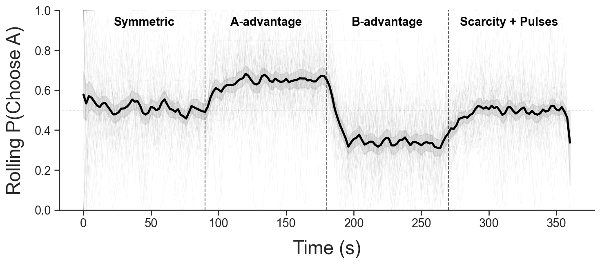
Note. Average rolling choice proportion (black line) with 95% confidence intervals (shaded band) across the four experimental phases (separated by vertical dashed lines). Lighter and thinner line paths represent individual participants.

Figure 2. Model comparison.
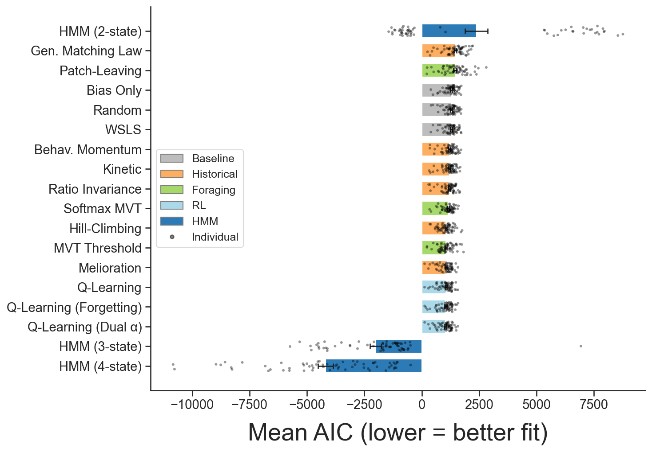

Note. Mean AIC across 60 sessions for all 14 models, organized by model family. Lower AIC indicates better fit. Note the discontinuous y-axis: HMM models (negative AIC) are separated from process models (positive AIC) by more than 3,000 units.

Figure 3. Phase-transition dynamics.

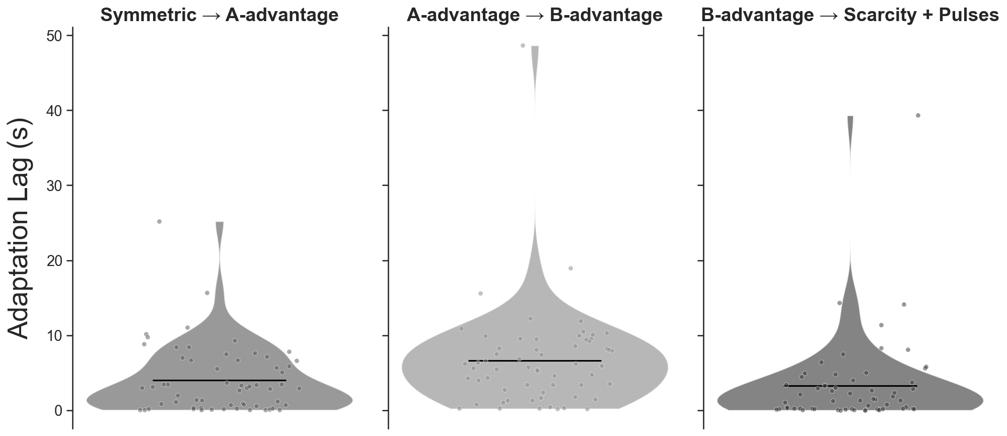

Note. Adaptation lags at each phase boundary, showing the distribution of time (in seconds) between the contingency change and the point at which choice allocation crossed the criterion threshold.

Figure 4. Hysteresis analysis of group average choice allocation as a function of latent response value (top panels) and contacted reinforcement (bottom panels) using 10 s rolling windows (each beginning and end of an arrow). Arrow directions show the temporal direction within each phase.

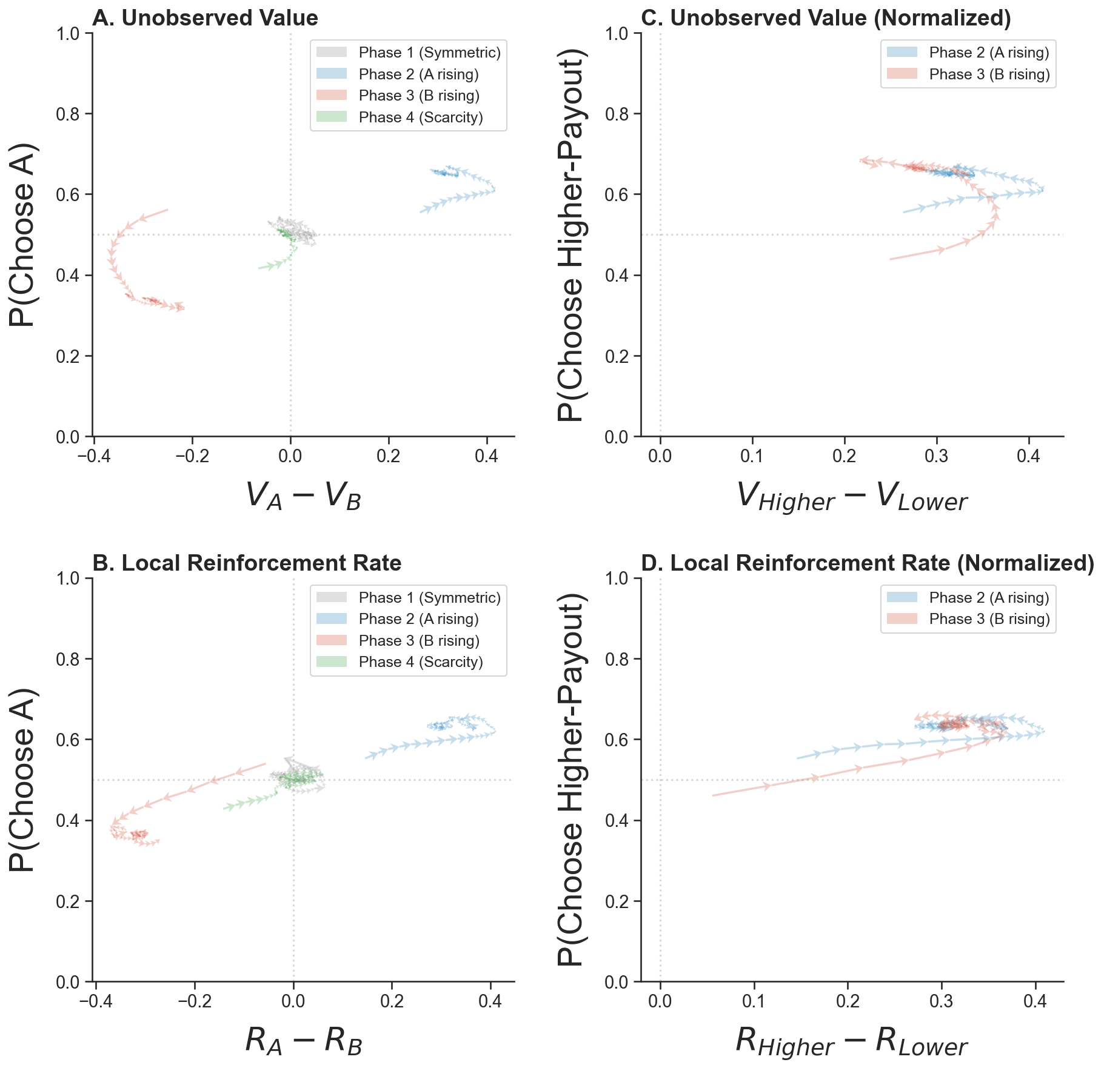
Figure 5. Observed proportion of responses to advantaged option (y-axis) relative to optimal proportion of responses to the advantaged option (x-axis) for each participant (marker) calculated from their individual average inter-click interval. The gray band shows ±5% around optimality.

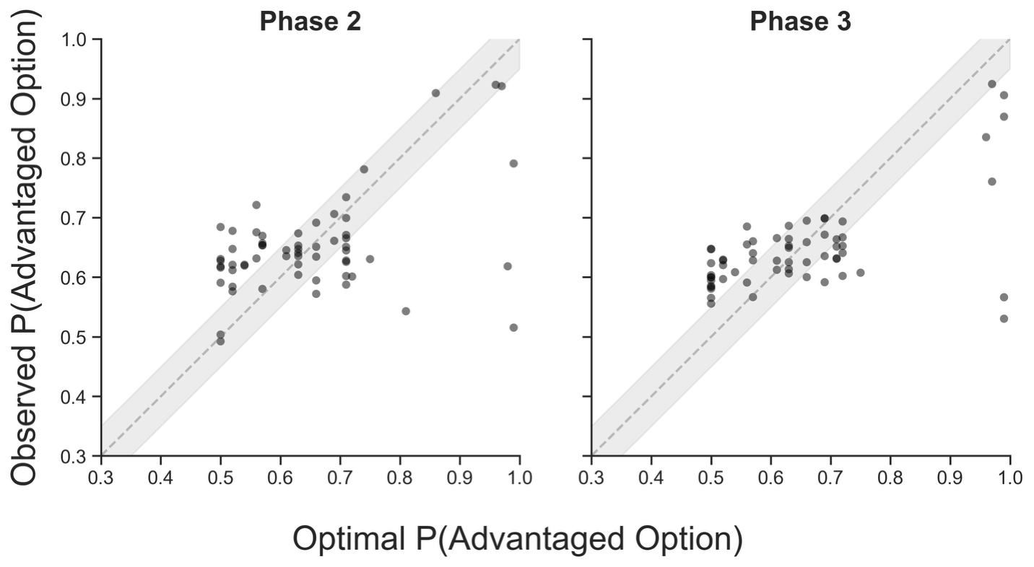
Figure 6. HMM analysis identifying state-space characteristics relative to response patterns (top and middle panels) and contact with reinforcement (bottom panel).

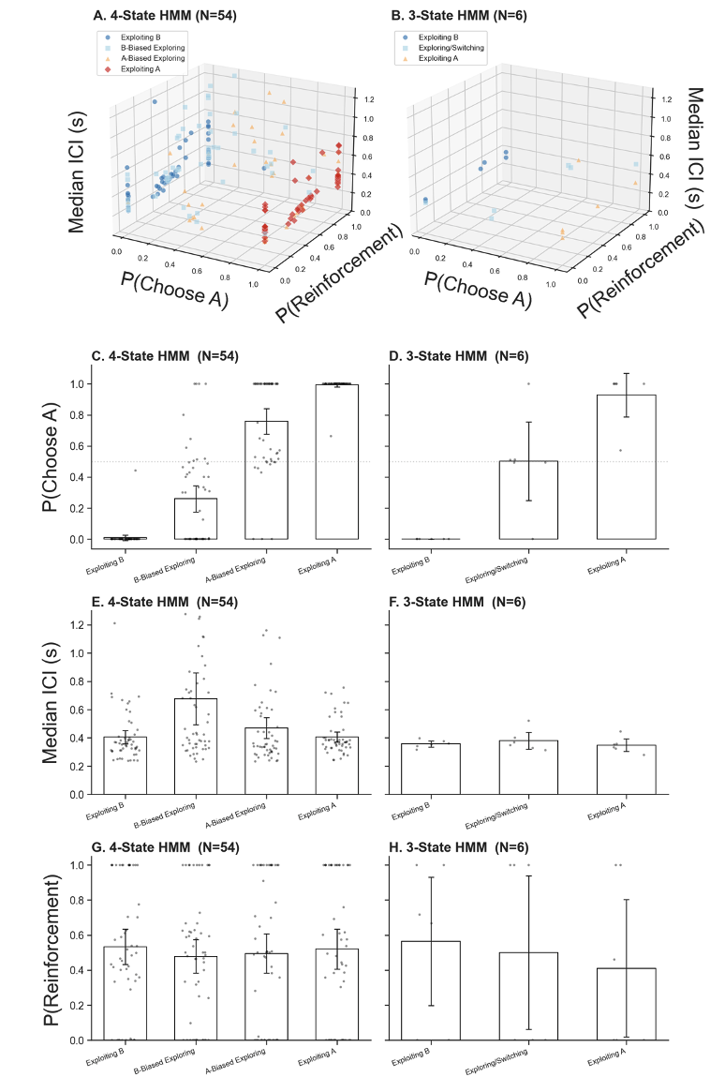
Figure 7. Convergent cross-mapping.

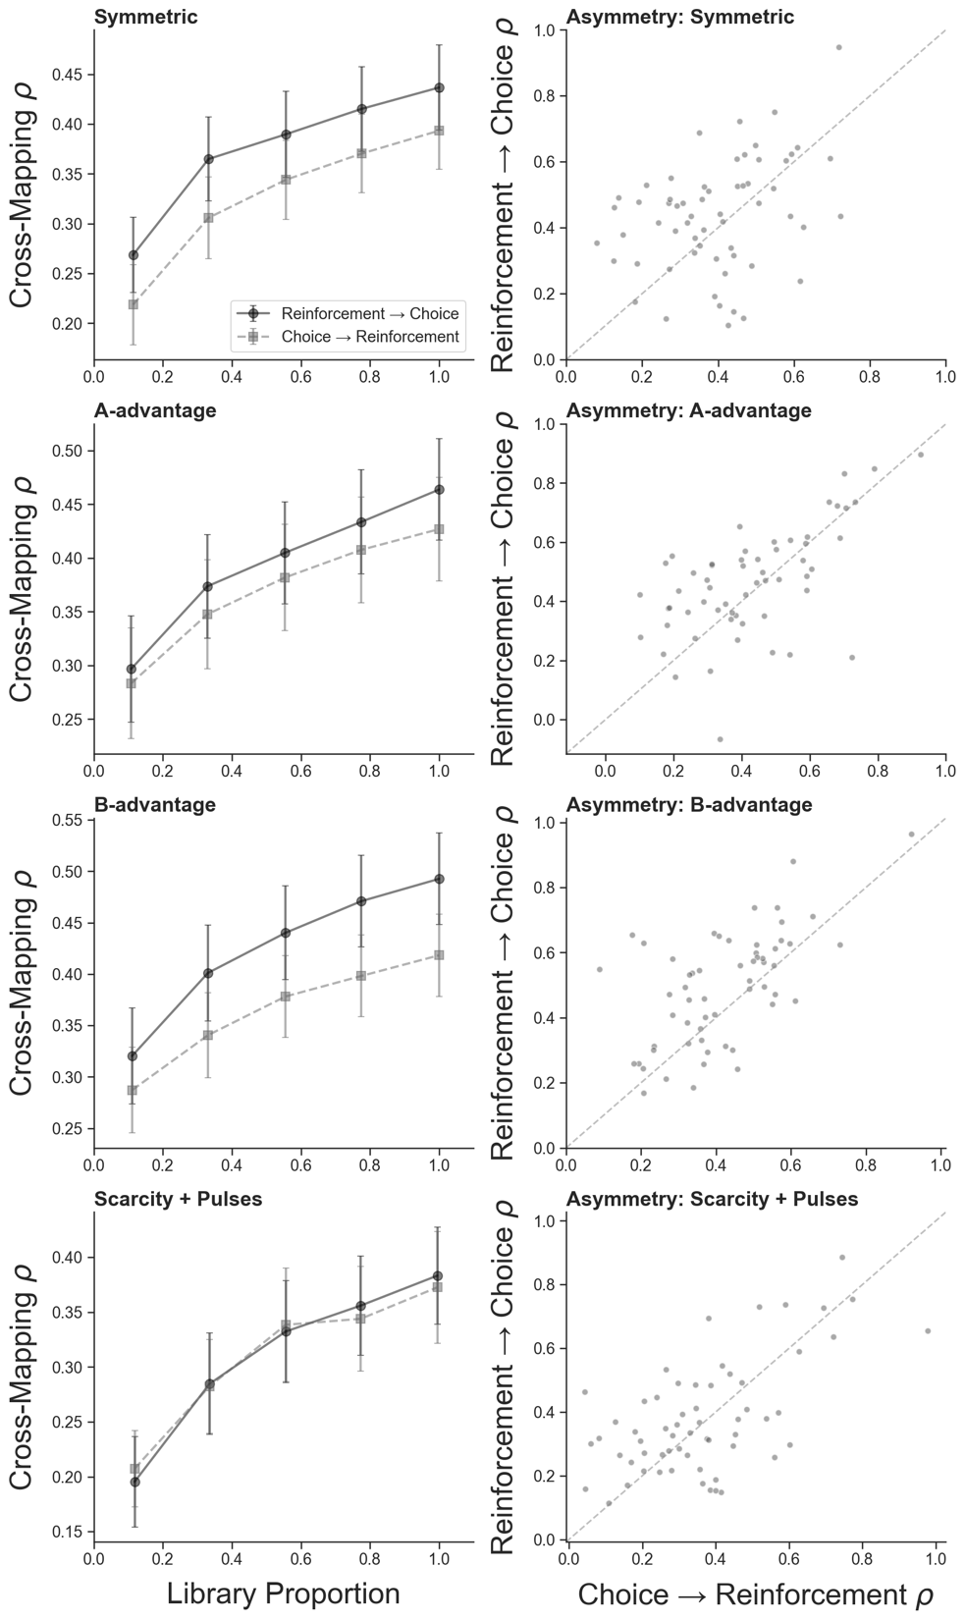

Note. CCM convergence plots showing increasing prediction skill with library size for the reward $to$ choice direction (stronger) and choice $to$ reward direction (weaker), confirming asymmetric causal coupling.
Figure 8. Recurrence plots of click rate per 3 s bins across the experiment for participants 1-31.
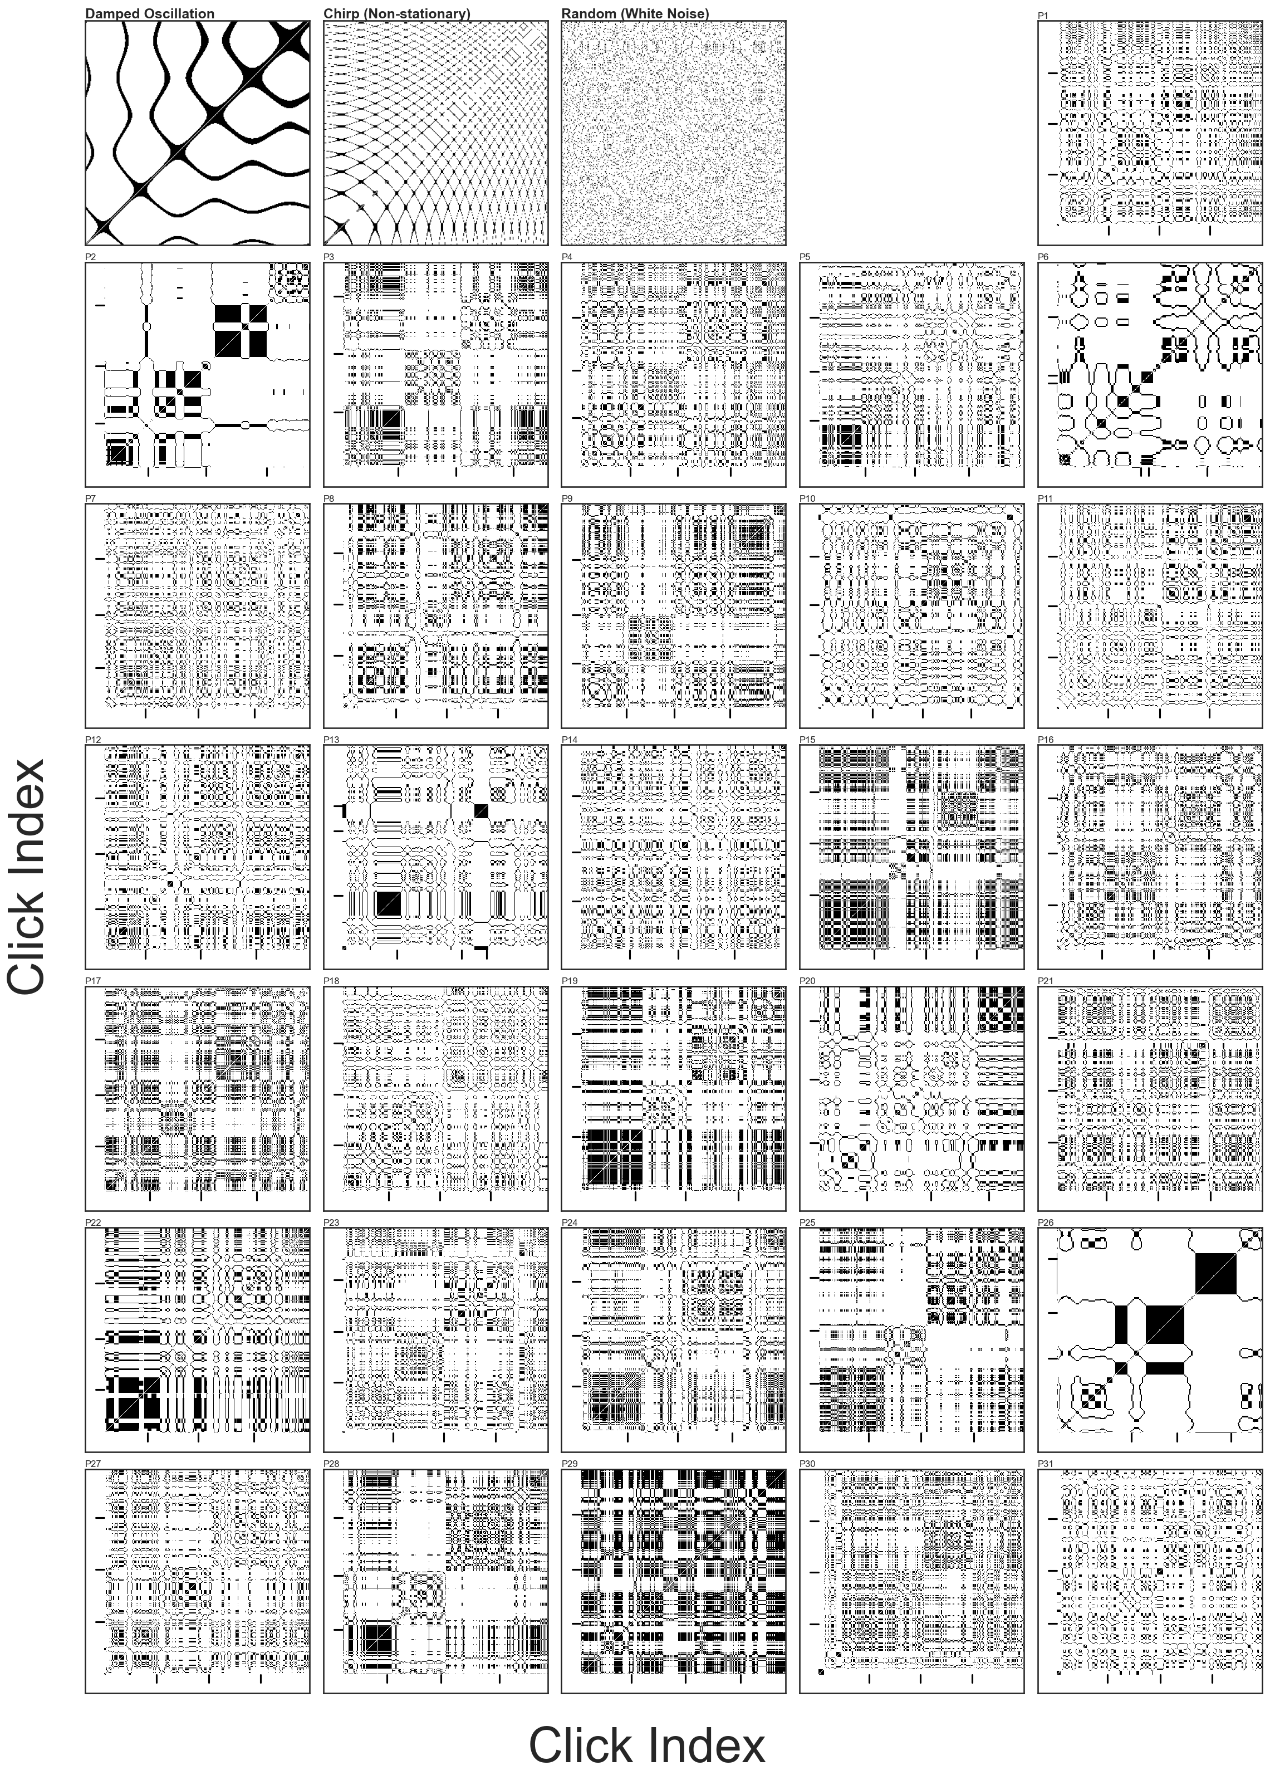
Figure 9. Recurrence plots of click rate per 3 s bins across the experiment for participants 32-60.
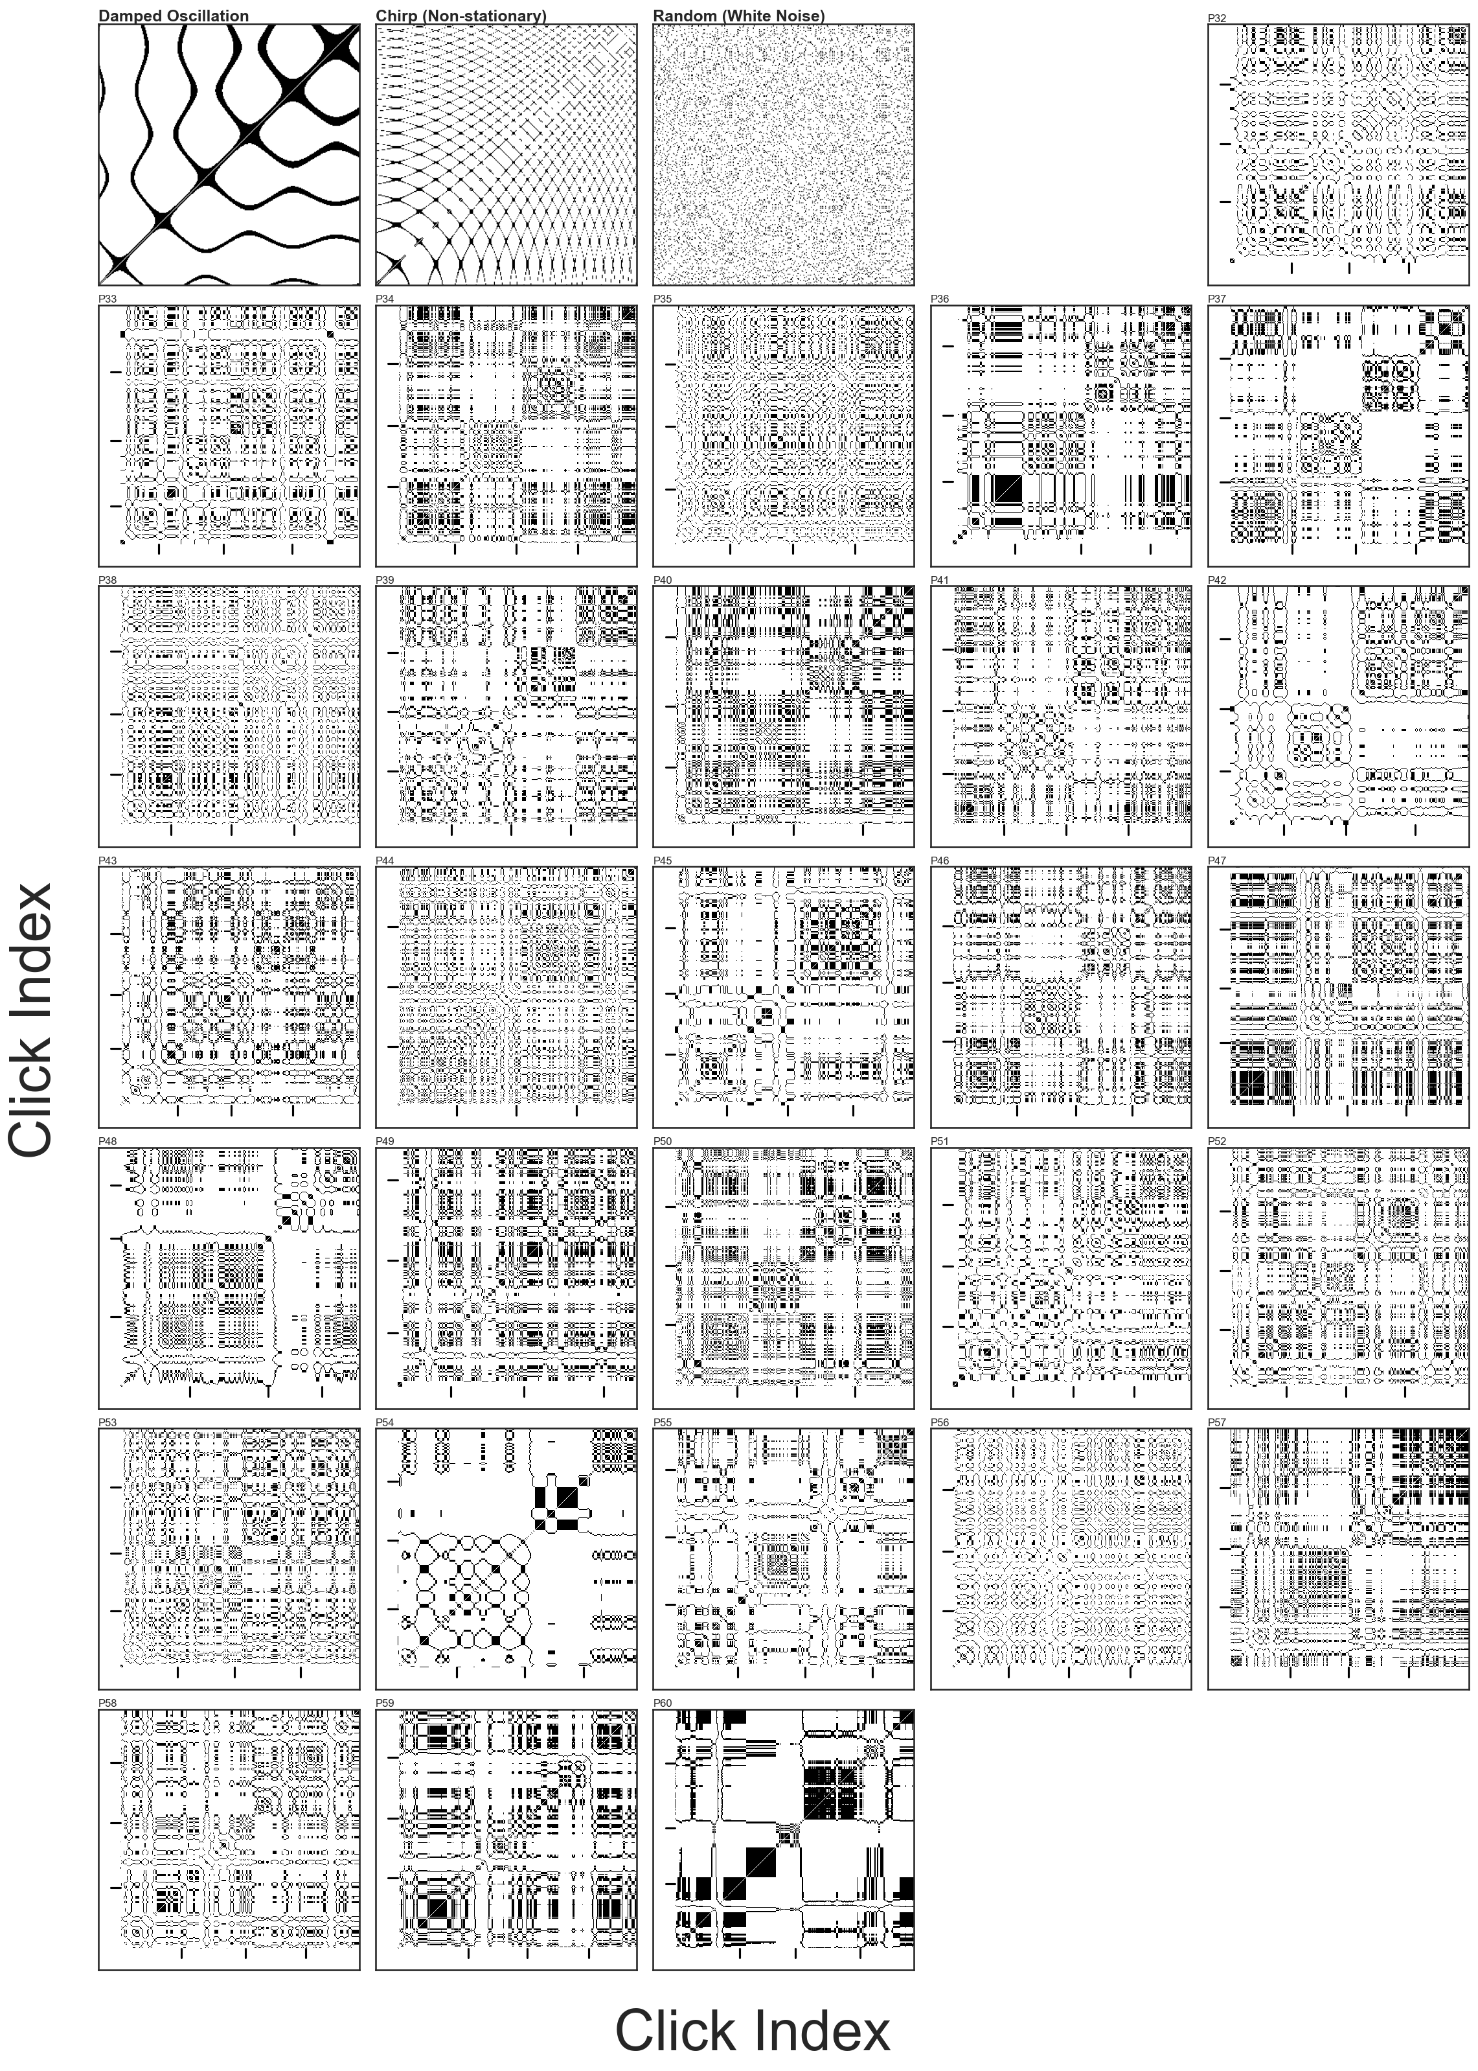

Figure 10. RQA metrics (x-axis) for each participant (markers) by experimental phase.

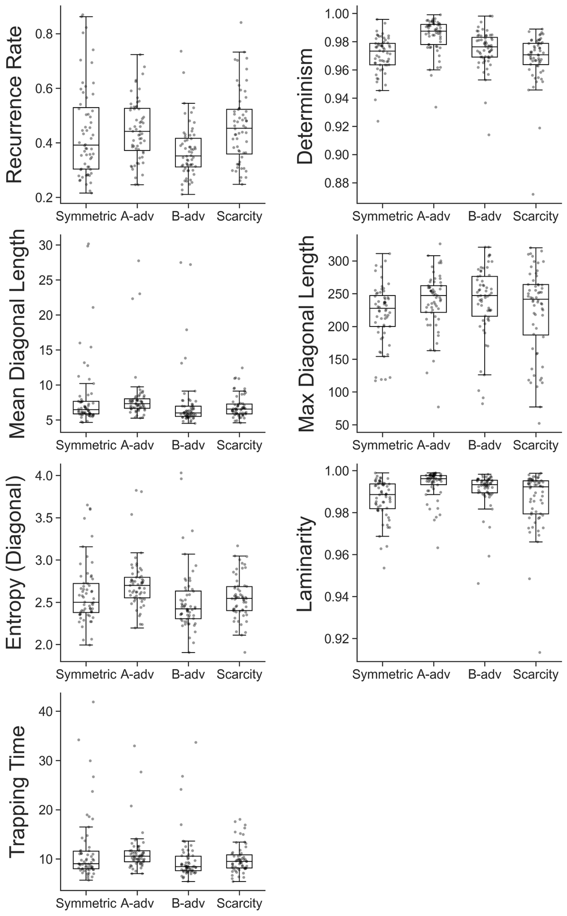
Supplemental hysteresis plots for individual participants.
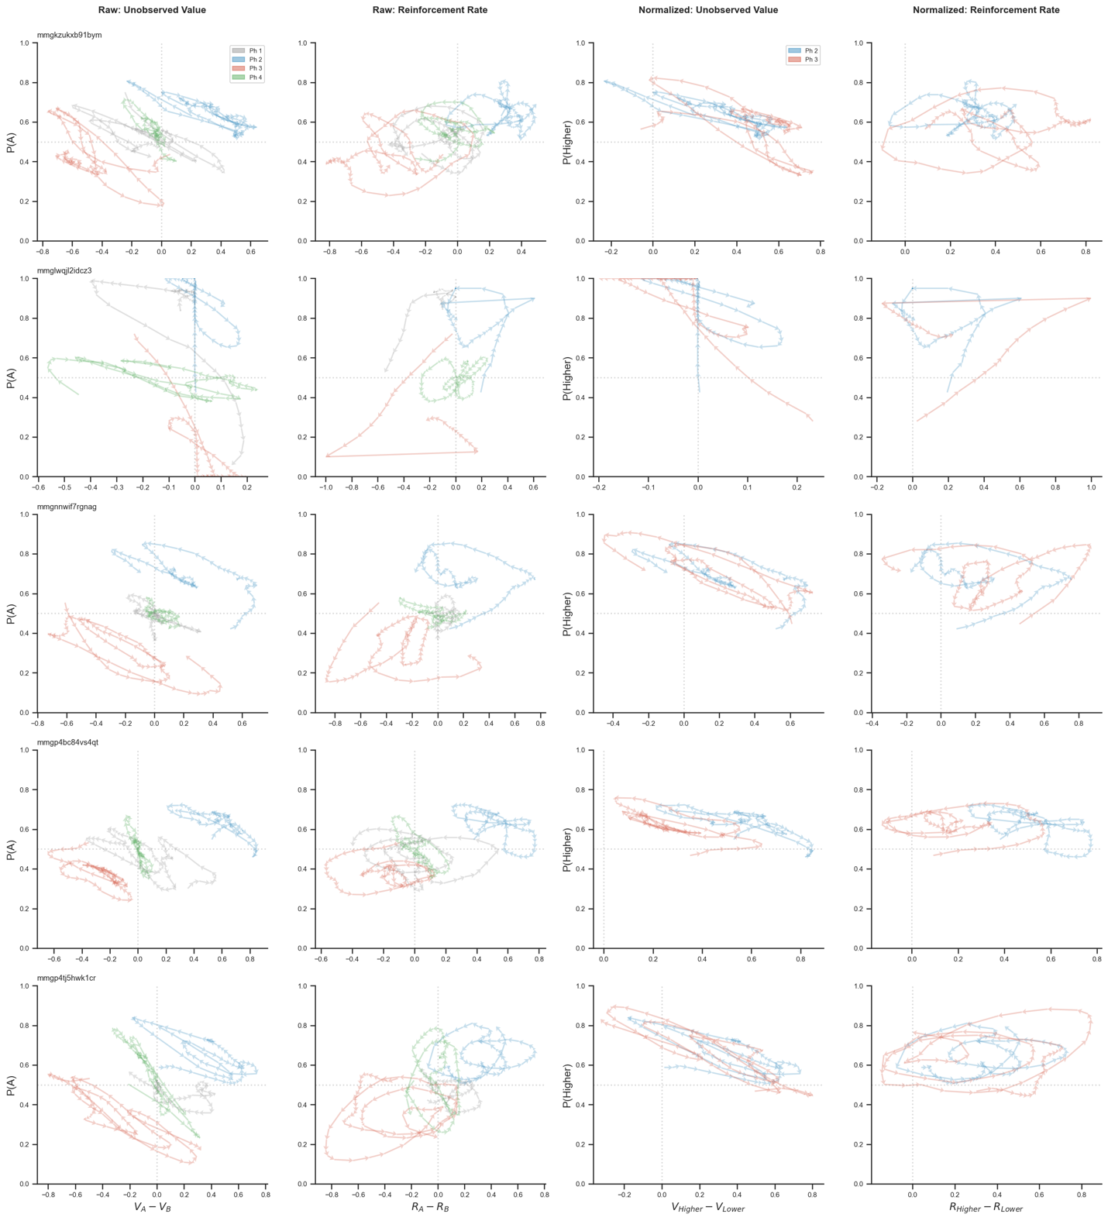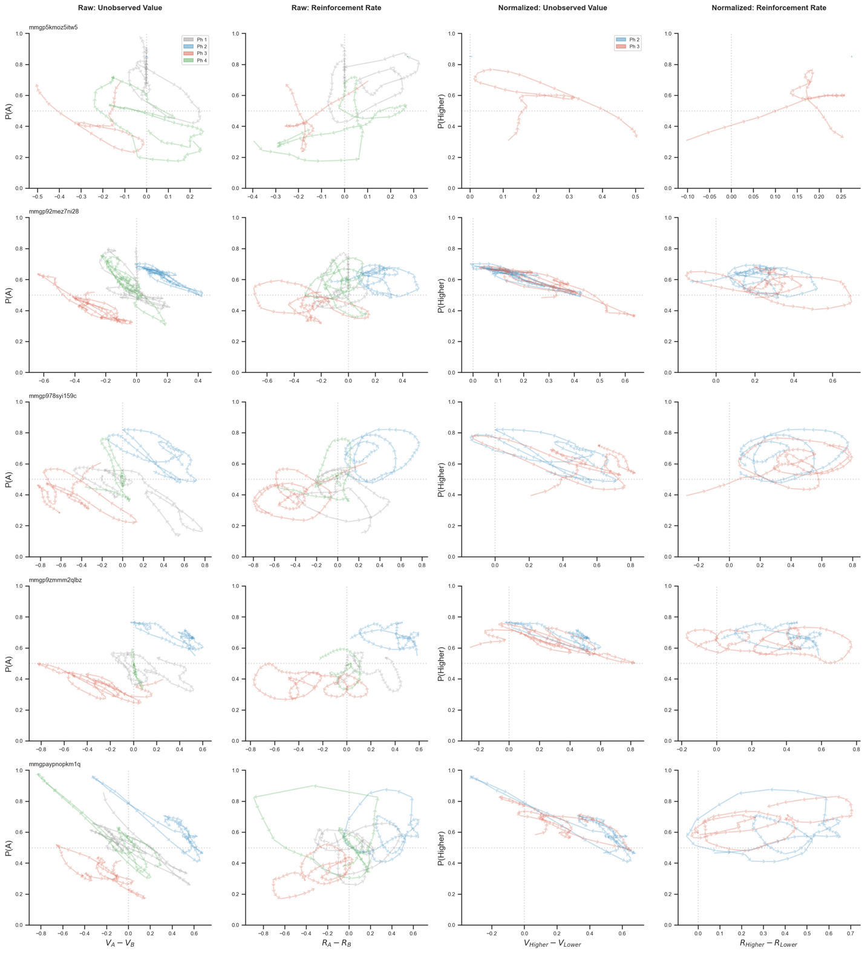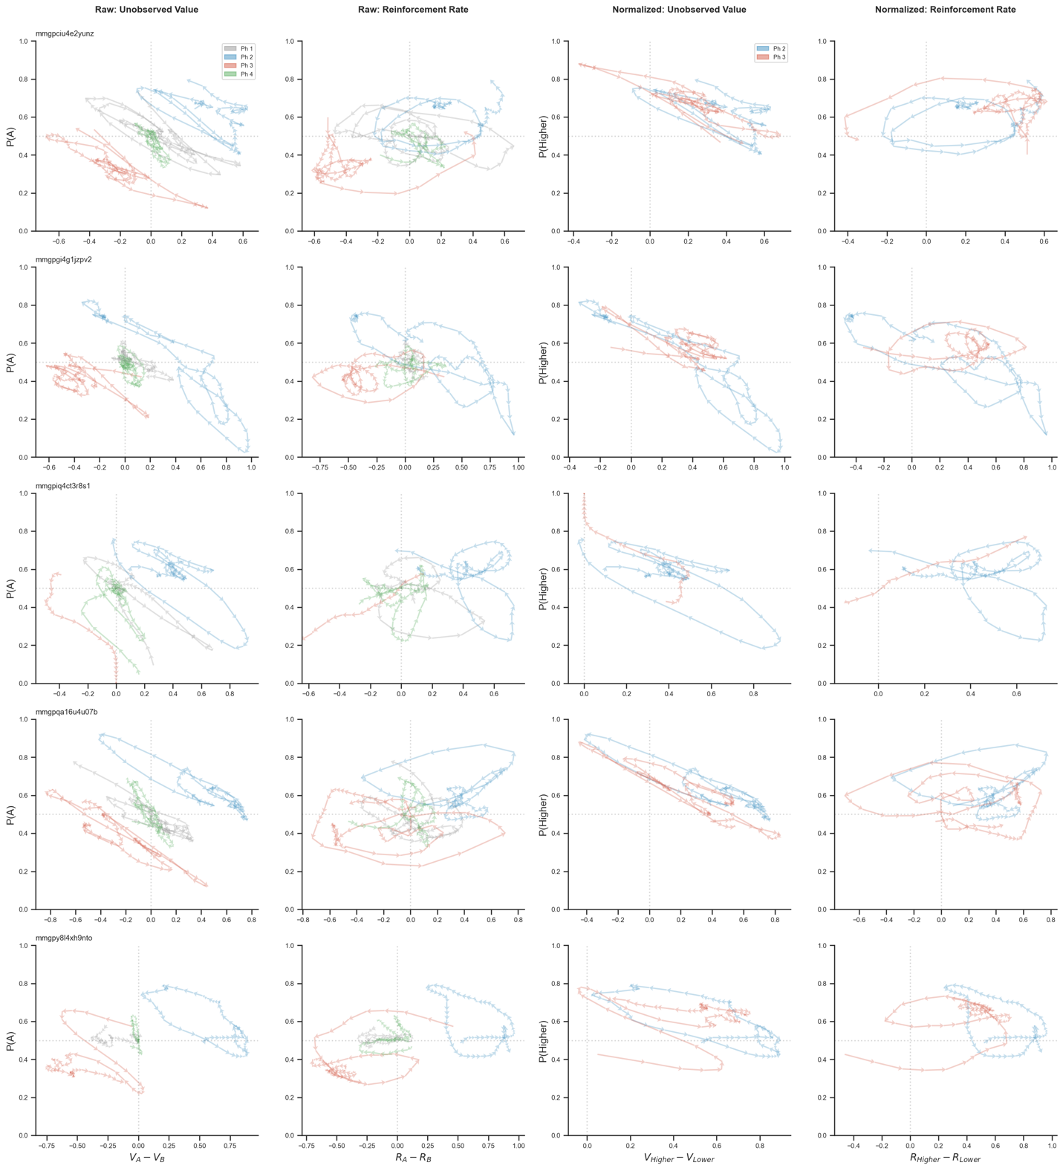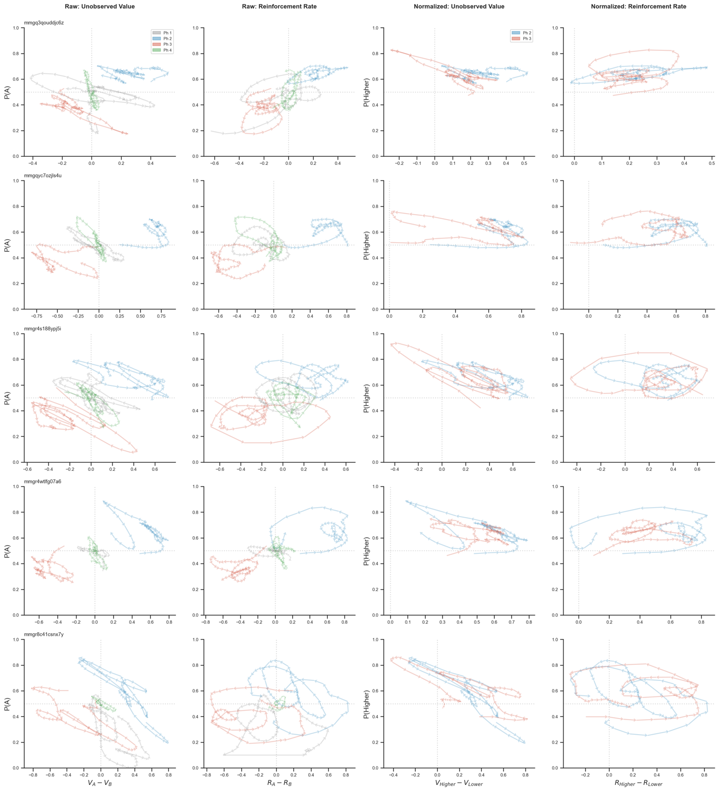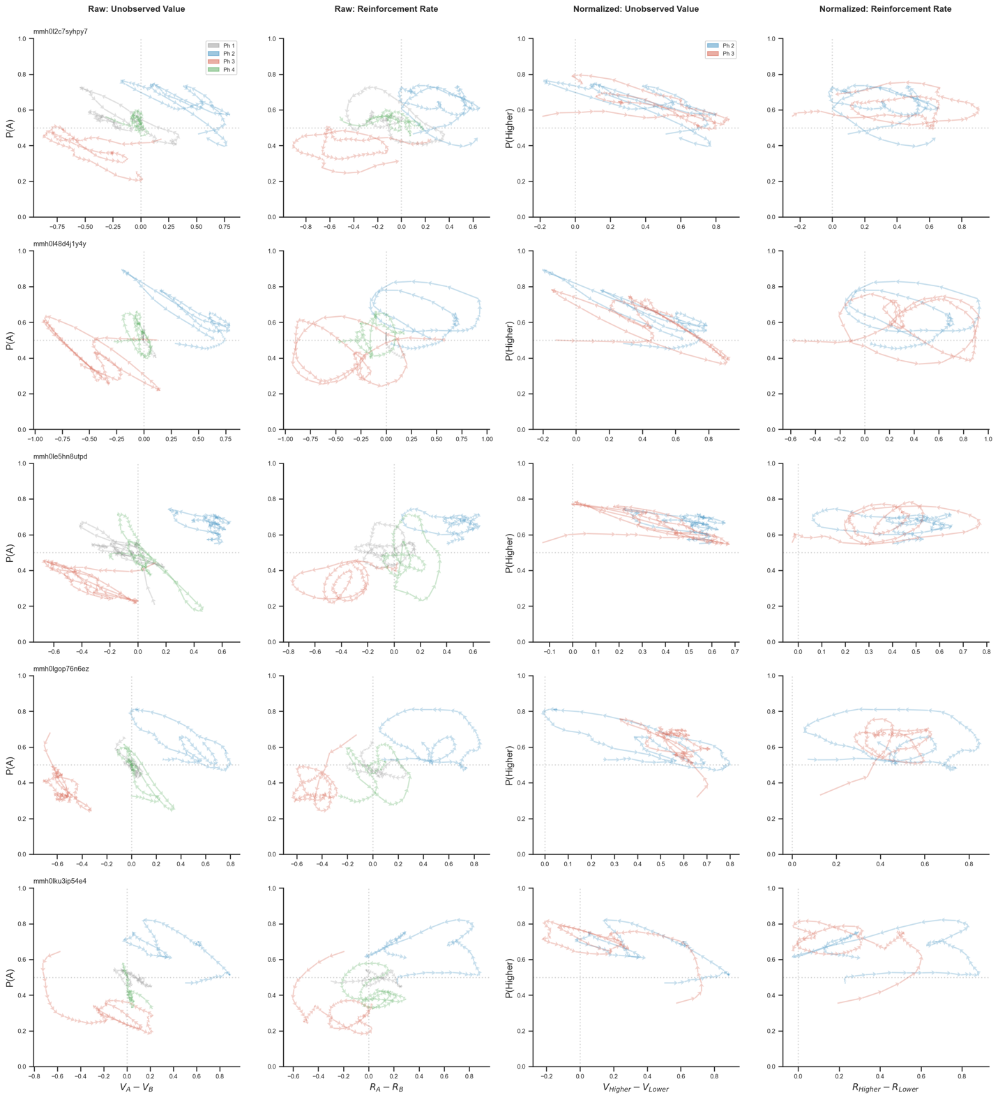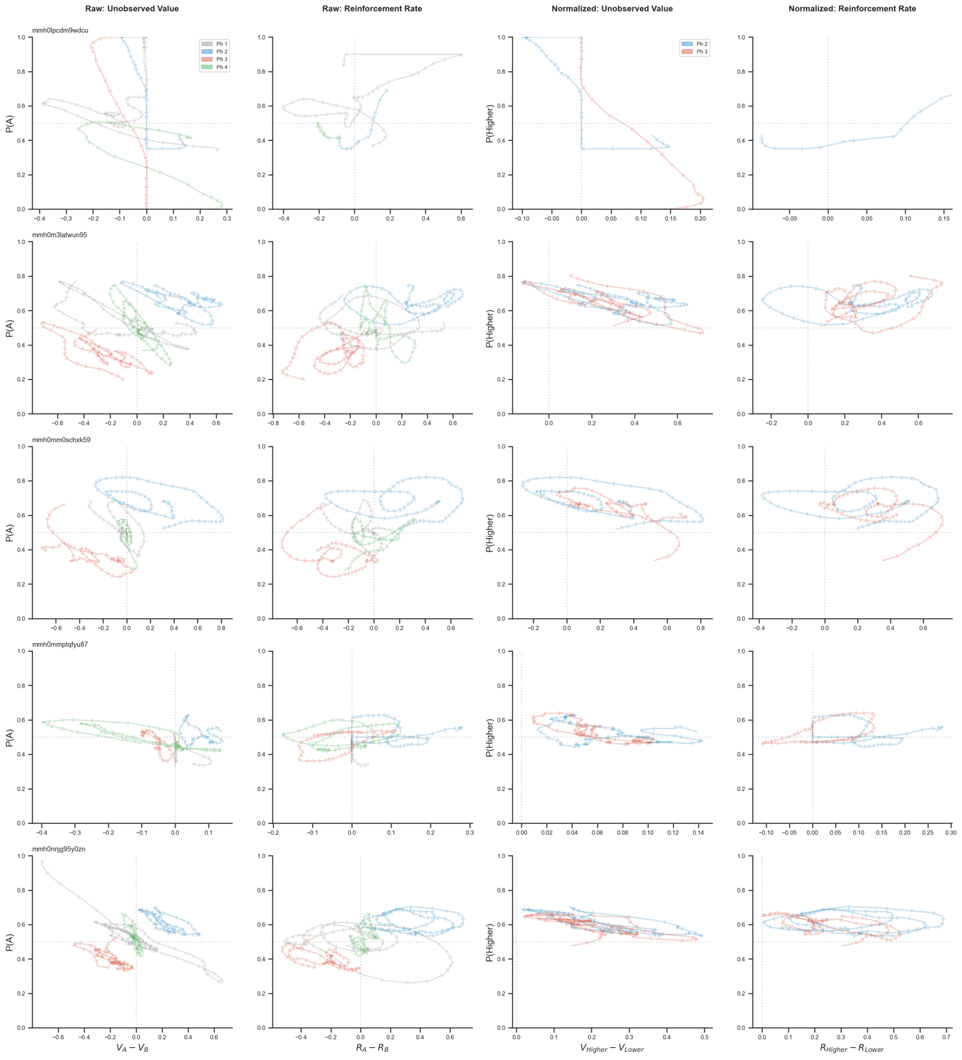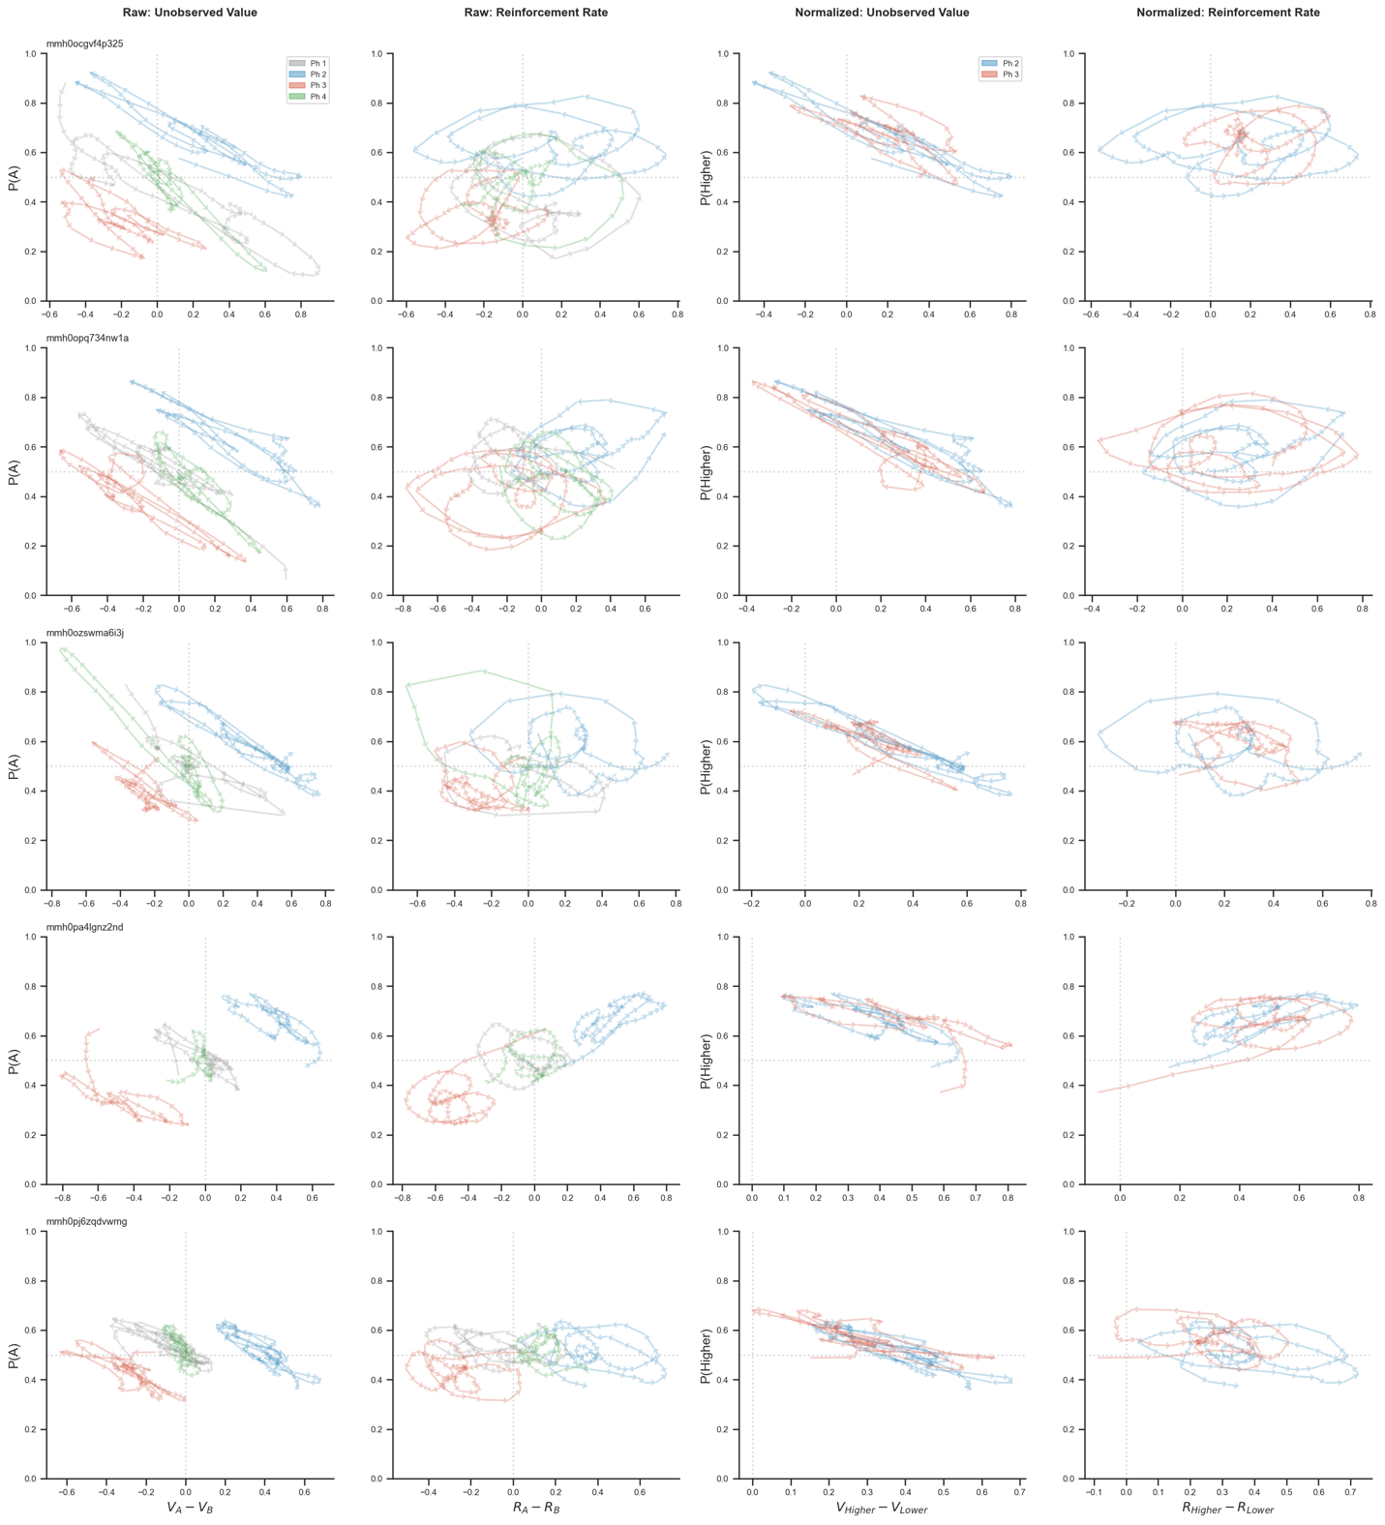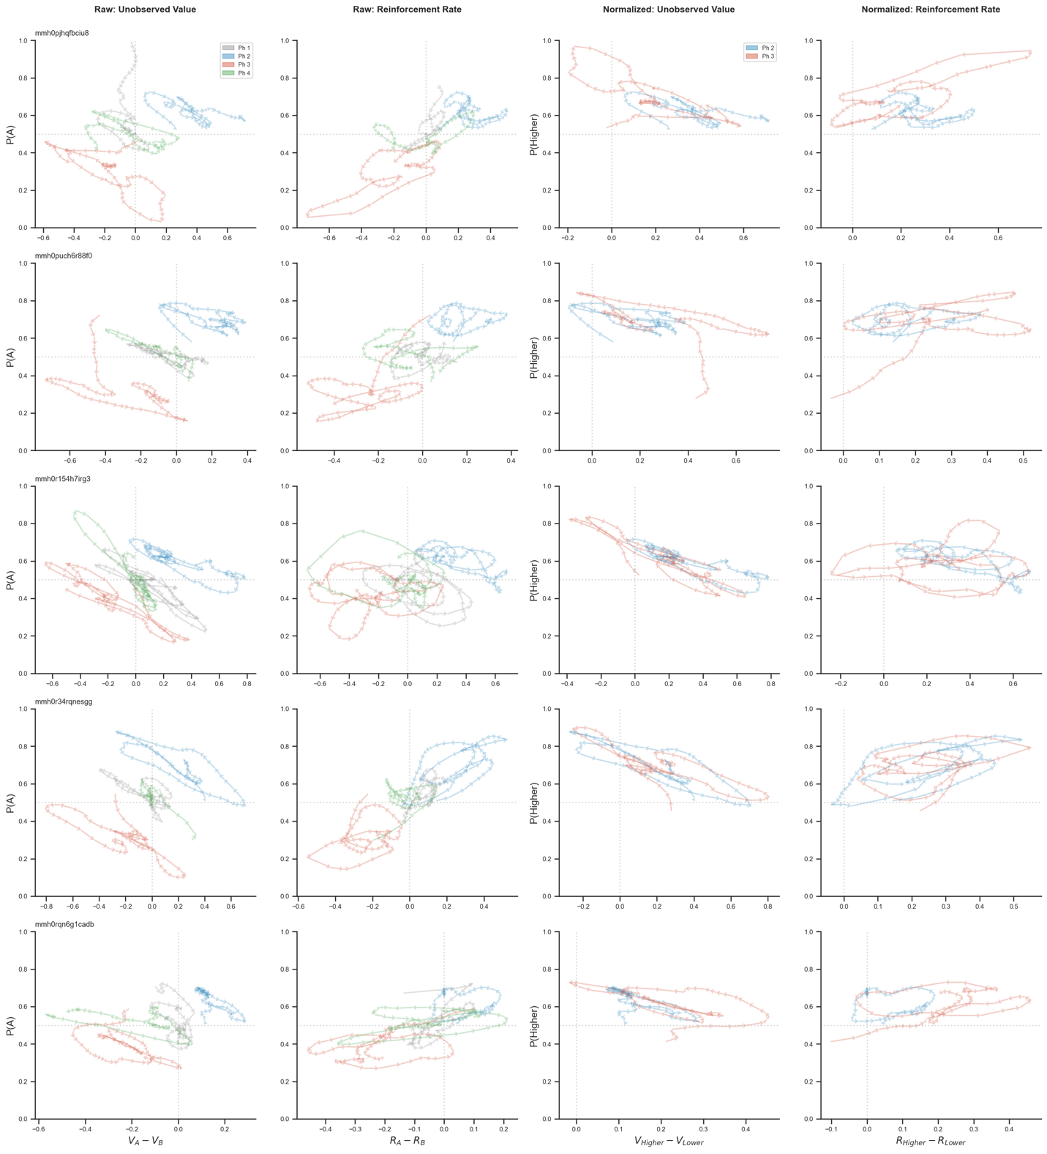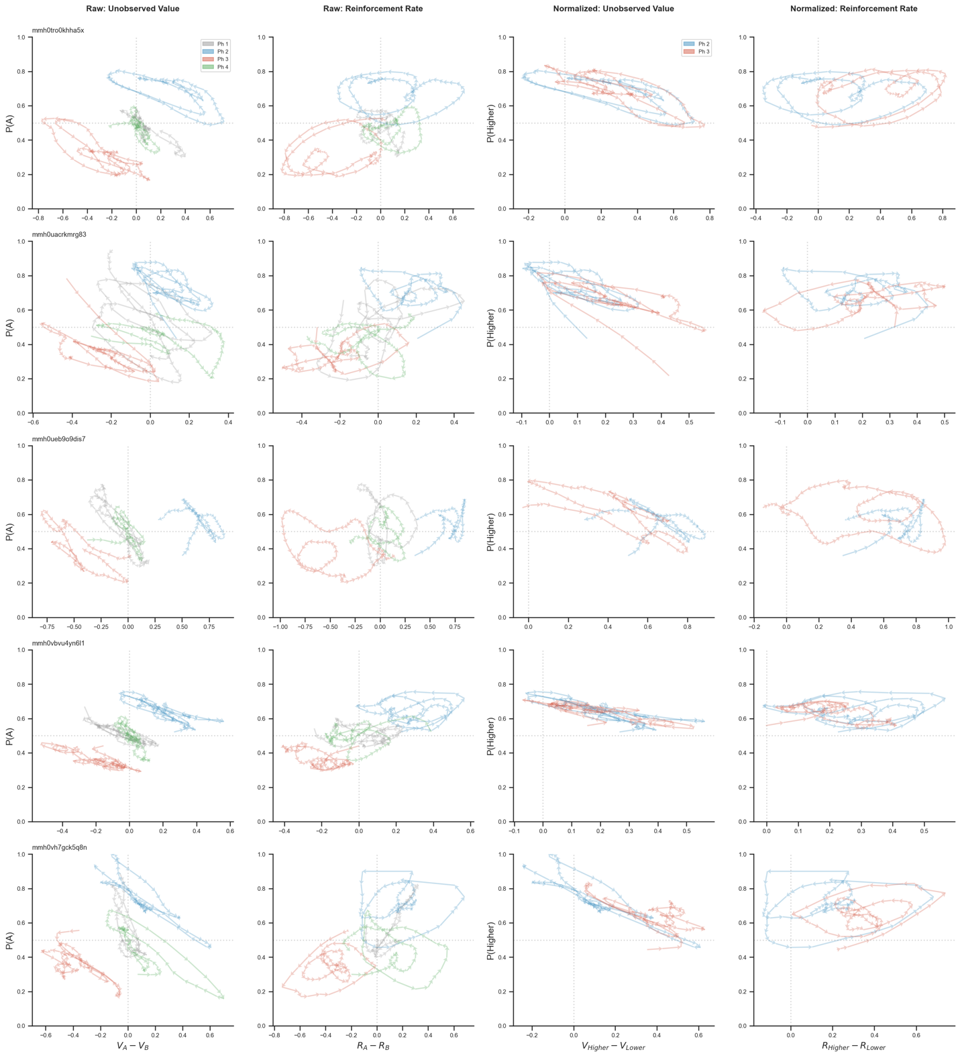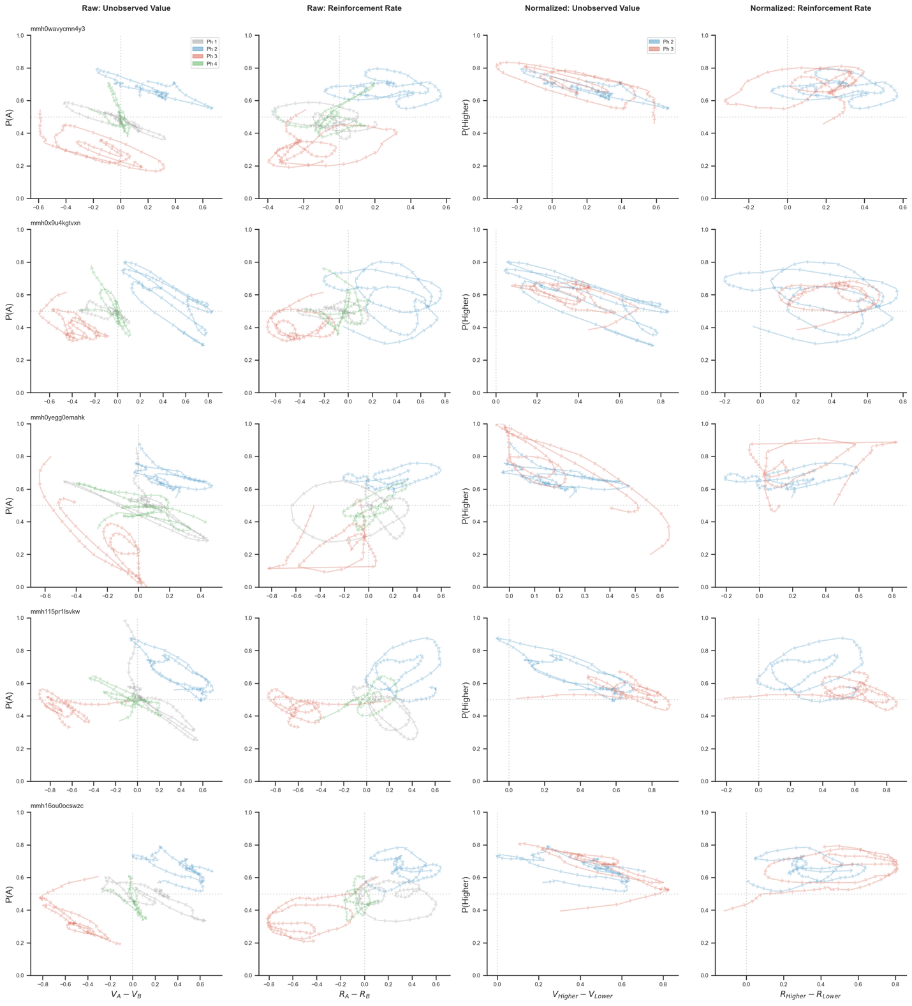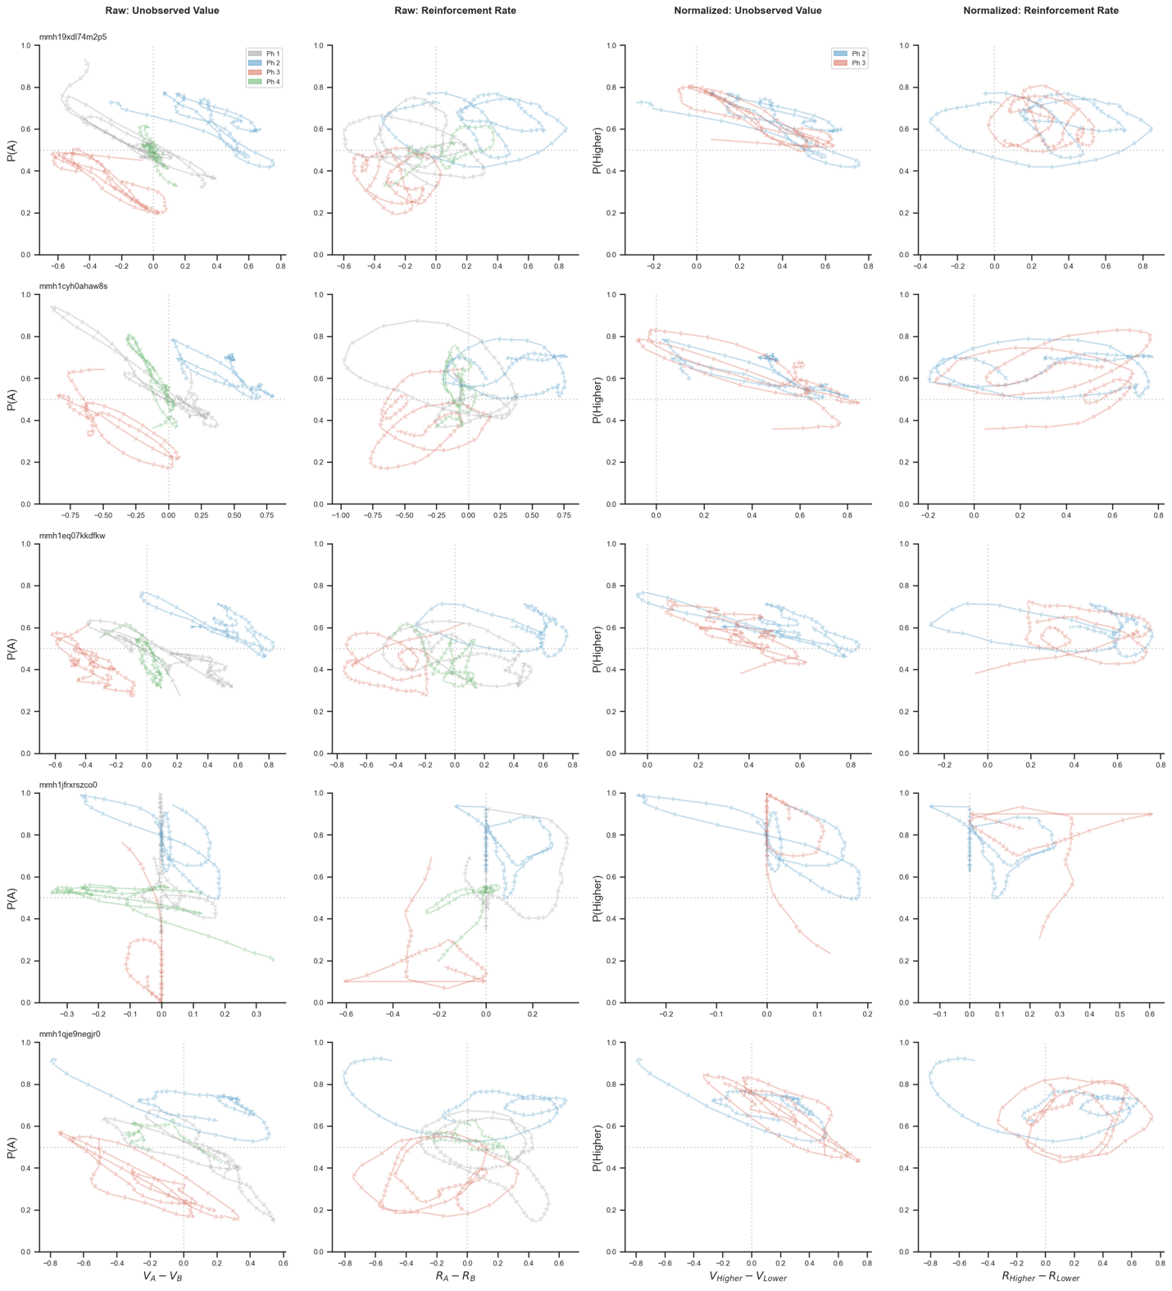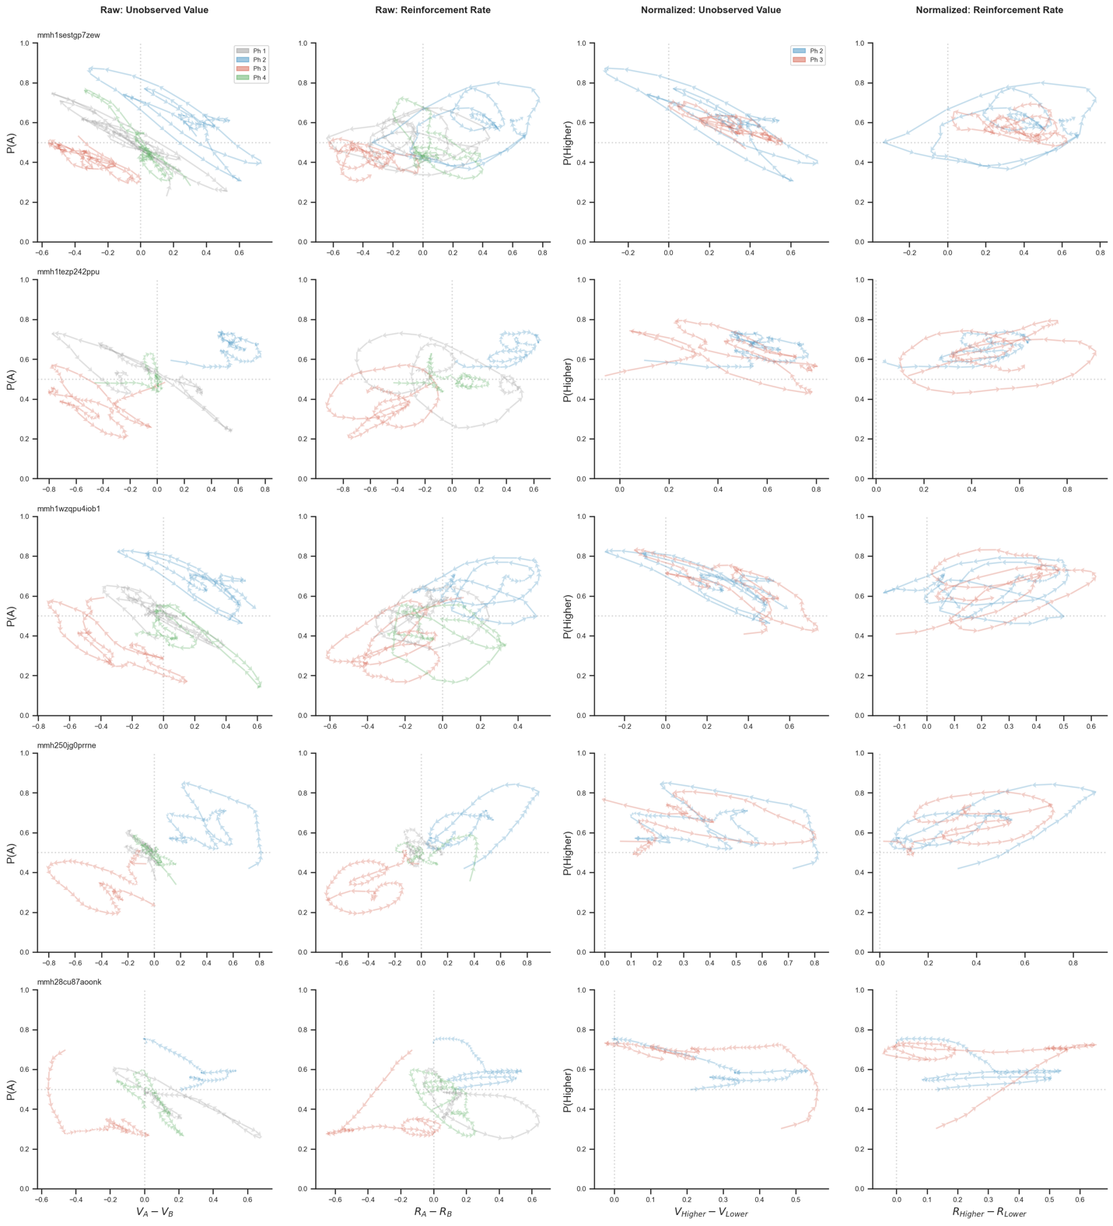

Supplemental convergence curves or individual participants.
